CONVENTION FOR THE SAFEGUARDING OF THE
INTANGIBLE CULTURAL HERITAGE
INTERGOVERNMENTAL COMMITTEE FOR THE
SAFEGUARDING OF THE INTANGIBLE CULTURAL HERITAGE
Seventeenth session
Rabat, Kingdom of Morocco
28 November to 3 December 2022
Item 6.b of the provisional agenda:
Examination of the reports of the first cycle of periodic reporting on the implementation of the Convention and on the current status of elements inscribed on the Representative List of the Intangible Cultural Heritage of Humanity by States Parties in Europe
Summary
This document presents the reports of States Parties in Europe submitted for the first cycle of periodic reporting on the implementation of the Convention and on the current status of elements inscribed on the Representative List.
Decision required: paragraph 16

Introduction
- Pursuant to Article 29 of the Convention as well as the relevant provisions in the Operational Directives (paragraphs 151-159 and 165-166, notably), the present session of the Committee is asked to examine the first cycle of periodic reports on the implementation of the Convention and on the current status of elements inscribed on the Representative List submitted by States Parties in Europe. This follows the amendment of the Operational Directives undertaken to reform the Periodic Reporting mechanism to align itself to the Overall Results Framework of the Convention, as amended by the ninth session of the General Assembly (Resolution 7.GA 10) and the revised reporting calendar based on a system of regional rotation covering a six-year period established by the thirteenth session of the Committee (Decision 13.COM 8).
- The present document covers the implementation of the new periodic reporting system in Europe (Section A), includes an assessment of the reports (Section B with Annex I and Annex II), and highlight challenges, opportunities and ways forward (Section C).
A. Implementation of the new periodic reporting system in Europe
- The Secretariat, in collaboration with the Regional Centre for the Safeguarding of the Intangible Cultural Heritage in South-Eastern Europe under the auspices of UNESCO (Category 2 Centre), organized two sets of capacity-building activities to support the implementation of the periodic reporting exercise in the region. The first set of activities, which took place between 22 January and 24 February 2021, was the working group sessions with 19 facilitators in the region in order to familiarize them with the new system of periodic reporting and strengthen their capacities to assist the country focal points. These sessions were then followed by the training for country focal points responsible for periodic reporting, which was held from 10 March to 16 April 2021 in English and French, with the objective to provide these focal points with the skills and knowledge required for completing the periodic reporting process. The training was attended by 69 country focal points (of which 75 per cent were female) from 44 States Parties, with the support of the facilitators and the Secretariat including the UNESCO Regional Bureau for Science and Culture in Europe in Venice.
- While the format of the training had to remain online, due to the ongoing situation of the COVID-19 pandemic, the modalities for delivering the training were improved with the integration of new online tools, such as Zoom polls and Padlets, to enhance the interaction among participants. The participants also had extensive access to enhanced training materials, including audio-visual material and articles, covering topics such as results-based reporting, data generation, participatory methodology and hands-on exercises on filling out the online periodic reporting form. Small working group sessions also allowed focal points from different countries in the region to work together more closely.
- Following these capacity-building activities, each focal point was better equipped to prepare her or his country report. The Secretariat also provided additional support by organizing two follow-up sessions for focal points in July and October 2021, followed by constant help desk assistance by the Secretariat for technical and content-related issues in filling in the periodic reporting form. As the deadline for submission of the reports (15 December 2021) coincided with the dates of the online sixteenth session of the Intergovernmental Committee (13-18 December 2022) intense internet traffic was expected on the website of the Convention during the period which risked compromising the submission of reports. Consequently, States were asked to initially submit the report prior to the Committee period, using the online periodic reporting Form ICH-10, and were then given the opportunity to complete and re-submit the report by 15 February 2022.
B. Assessment of the first cycle of periodic reports of States Parties in Europe
- Forty-two States Parties (out of forty-four) in the Europe region have submitted their periodic report on the implementation of the Convention and on the status of 177 elements inscribed on the Representative List (before the inscriptions at 16.COM), as the first cycle. The submitted reports ranged from seventy to 600 pages each in length, reaching a total of around 7600 pages of reports. The majority were submitted in English, with only six in French. The final reports are available at https://ich.unesco.org/en/6b-periodic-reporting-rl-01285 and the reporting countries are presented in the following table:
State Party | Date of ratification | Report (language(s) of submission)
Albania | 04/04/2006 | English
Andorra | 08/11/2013 | French
Armenia | 18/05/2006 | English
Austria | 09/04/2009 | English
Azerbaijan | 18/01/2007 | English
Belarus | 03/02/2005 | English
Belgium | 24/03/2006 | English and French
Bosnia and Herzegovina | 23/02/2009 | English
Bulgaria | 10/03/2006 | English
Croatia | 28/07/2005 | English
Cyprus | 24/02/2006 | English
Czechia | 18/02/2009 | English
Denmark | 30/10/2009 | English
Estonia | 27/01/2006 | English
Finland | 21/02/2013 | English
France | 11/07/2006 | French
Georgia | 18/03/2008 | English
Germany | 10/04/2013 | English
Greece | 03/01/2007 | English
Hungary | 17/03/2006 | English
Iceland | 23/11/2005 | English
Ireland | 22/12/2015 | English
Italy | 30/10/2007 | English
Latvia | 14/01/2005 | English
Lithuania | 21/01/2005 | English
Luxembourg | 31/01/2006 | French
Malta | 13/04/2017 | English
Monaco | 04/06/2007 | French
Netherlands | 15/05/2012 | English
North Macedonia | 13/06/2006 | English
Norway | 17/01/2007 | English
Poland | 16/05/2011 | English
Portugal | 21/05/2008 | English
Republic of Moldova | 24/03/2006 | English
Romania | 20/01/2006 | English
Serbia | 30/06/2010 | English
Slovakia | 24/03/2006 | English
Slovenia | 18/09/2008 | English
Spain | 25/10/2006 | English
Sweden | 26/01/2011 | English
Switzerland | 16/07/2008 | French
Türkiye | 27/03/2006 | English

- The analysis of the periodic reports in Europe was initiated with a thorough data processing and statistical analysis of the reports in June 2022, in collaboration with a data specialist from the agency ‘Stat sans Limites’. Based on the experience with the Latin America and the Caribbean region (2021 cycle), the data output models used for the Europe cycle were updated so that the data and comments from the reports, which were structured around the twenty-six core indicators and the eighty-six assessment factors of the Overall Results Framework, could be presented for qualitative analysis in a user-friendly way. Following that, the in-depth and qualitative content analysis was undertaken by a group of experts from the region, experienced in monitoring and evaluation in the areas of inventories, safeguarding and policy development, in cooperation with the Institute of Ethnology and Social Anthropology of the Slovak Academy of Sciences. The experts undertook a thorough quantitative and qualitative analysis, focusing on identifying key issues related to intangible cultural heritage safeguarding in the different countries, as well as certain divergent and convergent trends in the region. A cross-cutting thematic analysis method was also applied in order to highlight some key analytical areas, which are illustrated by specific and relevant country examples in line with the priority areas of UNESCO, such as gender, youth, indigenous peoples, and sustainable development.
- An analytical overview of the reports can be found in Annex I of this document. It presents some general observations and key analytical findings from the periodic reports of the States Parties in Europe. While the analytical overview introduces some of the common trends, challenges and opportunities related to safeguarding intangible cultural heritage as reported by the countries, further in-depth analysis of the forty-two reports will continue throughout 2022 and 2023. An in-depth detailed analytical report will therefore be presented to the Committee at its eighteenth session in November/December 2023.
- In Annex I, the specific findings from the reports are also shared according to the following eight thematic areas in the Overall Results Framework: (a) Institutional and human capacities; (b) Transmission and education; (c) Inventorying and research; (d) Policies as well as legal and administrative measures; (e) The role of intangible cultural heritage and its safeguarding in society; (f) Awareness-raising; (g) Engagement of communities, groups and individuals as well as other stakeholders; and (h) International engagement. In addition, a brief analysis is provided on key aspects related to the status of the elements on the Representative List in the region, such as the assessment of their viability and efforts to promote or reinforce the elements.
- Some of the key findings include high levels of inclusive participation of communities, groups and individuals concerned in intangible cultural heritage safeguarding in most of the reporting countries, with specific attention to minorities and/or indigenous peoples. Community participation is supported by policy frameworks and participative research and inventorying processes. Many countries have reported the existence of a culture of volunteering and participating in community organizations, part of which are established as non-governmental organizations. In relation to international and regional cooperation for safeguarding, reporting countries have engaged extensively with the international mechanisms of the Convention, namely the listing mechanisms. International cooperation has been particularly encouraged by 28 multinational inscriptions on the Representative List and one multinational programme on the Register of Good Safeguarding Practices. At the regional level, cooperation has been facilitated by multilateral organizations and frameworks such as the Council of Europe and the European Union (EU). An important role has also been played by UNESCO Chairs, accredited NGOs and the Regional Centre for the Safeguarding of Intangible Cultural Heritage in South-Eastern Europe under the auspices of UNESCO (Category 2 Centre). According to reporting countries, the use of digital tools was fundamental for implementing the Convention, as it allowed for broader participation and information sharing, especially considering the threats posed by the COVID-19 pandemic.
- While the majority of the 26 indicators under the Overall Results Framework are related to measuring and monitoring the States Parties’ implementation at the national level, there are two indicators that require monitoring at the global level. These are indicators 23 ‘Number and geographic distribution of NGOs, public and private bodies, and private persons involved by the Committee in an advisory or consultative capacity’ and 26 ‘ICH Fund effectively supports safeguarding and international engagement’, which are both categorized under the thematic area ‘International engagement’. Annex II of this document therefore presents the monitoring data and information relevant to these two indicators and assessment factors.
- Challenges, opportunities and the way forward
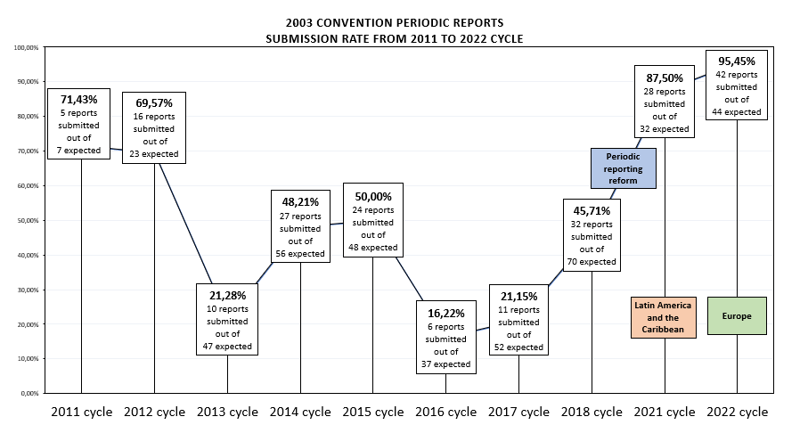
- Following the first experience with the periodic reporting exercise in Latin America and the Caribbean (2021 cycle), the implementation of the reformed system of periodic reporting continues to show promising results in the 2022 cycle with the submission rate of reports at 95.5 per cent (forty-two reports submitted out of a total of forty-four expected) in Europe. The submission rate may be compared to the past reporting cycles in the following charts:

- In addition to the high submission rate, the implementation of periodic reporting in Europe has yielded other positive results. One of the main achievements is the awareness that has been raised among States Parties on the importance of broader participation in the reporting process of key stakeholders at the national level, including living heritage bearers and practitioners, national institutions, NGOs, communities, and academia. Furthermore, at the regional level, periodic reporting has served as a platform for dialogue and peer-to-peer exchange among countries, by sharing knowledge and experience related to intangible cultural heritage safeguarding. Concretely, the ‘European Network of Focal Points for the UNESCO 2003 Convention’ was created, initially with the objective to collaborate in the countries’ preparation of their periodic report and is now expected to further strengthen regional cooperation on various issues and actions related to safeguarding living heritage.
- While much has been achieved through the implementation of periodic reporting in Europe, the implementation process has also been assessed to be very challenging by many countries. This is not only due to the ongoing situation of the global health crisis of COVID-19, but also due to the extensive scope and complexity of the exercise itself. Some of the challenges have already been identified through the reporting experience in Latin America and the Caribbean and reiterated by countries in Europe, as follows:
- The short timeframe for States Parties to undertake the reporting process in a substantive manner, especially for organizing broader consultation with relevant stakeholders;
- The complexity of the reporting form, structured around twenty-six core indicators and eighty-six assessment factors, and the difficulty in collecting and analysing data and information across a wide range of thematic areas, of which many are of a cross-cutting nature;
- The lack of pertinent data and information in the relevant areas of safeguarding, readily available for review and analysis. Further issues reported were difficulties in convincing partners on the importance of reporting on living heritage and receiving appropriate data and information from them;
- The limited resources, human and financial, available within each country to support the lengthy and demanding reporting process. In many cases, it was observed that the country focal point was working alone without any additional support to assure the country’s participation in the online training, data collection, the consultation processes and the drafting of the report;
- The Secretariat also witnessed staff turnover in several countries throughout the reporting process, which requires the engagement of focal points from the moment they receive the training up to the submission of the report. While the Secretariat provided access to all training materials and recordings of the training sessions to the new focal points, it was particularly challenging for them to ensure the preparation and submission of their country’s reports.
- As the periodic reporting system completes its second year of implementation, it is in the process of gaining further experience as an effective self-monitoring tool for the States. While the lessons learnt through the Latin American and Caribbean experience have helped in integrating a separate training session for facilitators in Europe to support the country focal points in their preparation of the reports, the exercise in Europe also concluded with the successful implementation of interactive and participatory capacity-building activities, which are contributing to the reporting exercise in the Arab States region (2023 cycle). The challenges that each region address will help seek further improvements and identify short- and mid-term solutions to the periodic reporting system, so that it may serve as a dynamic monitoring tool to assess current safeguarding measures and customize future strategies and key actions of safeguarding within each State.
- The Committee may wish to adopt the following decision:
DRAFT DECISION 17.COM 6.b
The Committee,
- Having examined document LHE/22/17.COM/6.b Rev. and its annexes,
- Recalling Articles 7, 29 and 30 of the Convention concerning reports by States Parties, and Chapter V of the Operational Directives,
- Further recalling Decision 12.COM 10, Resolution 7.GA 10, Decision 13.COM 8, Decision 14.COM 8, as well as document LHE/19/14.COM/8,
- Underlining the importance of periodic reporting on the implementation of the Convention and on the current status of elements inscribed on the Representative List, which serves as a key monitoring tool for States Parties to measure the progress of implementing safeguarding measures at the national level and plan the future direction of safeguarding,
- Expresses its satisfaction with the implementation of the first cycle of periodic reporting in the Europe region and welcomes the positive results achieved from the 2022 cycle, especially the significantly high rate of submission of the reports by States Parties;
- Congratulates the forty-two States Parties in Europe that have submitted their reports for the 2022 reporting cycle and commends them for their efforts to complete the periodic reporting exercise;
- Expresses its appreciation to the Secretariat for ensuring an effective implementation of the periodic reporting exercise for the second consecutive year by providing concrete and comprehensive support to the States Parties concerned in their reporting process through capacity-building activities and ongoing follow-up;
- Acknowledges the quantitative and qualitative analysis that has been conducted for the reports from the Europe region, welcomes the key findings from the analytical overview of the reports, as presented in the annexes of document LHE/22/17.COM/6.b;
- Takes note with interest of the common trends, challenges, opportunities and priority areas related to intangible cultural heritage as reported by States Parties, as well as the different safeguarding approaches and methodologies adopted by them to implement the Convention, and looks forward to further detailed analyses of the reports, which will be presented to the eighteenth session of the Committee in 2023 and contribute to the reflection year in 2026;
- Recalls that the designations employed in the reports presented by the States Parties do not imply the expression of any opinion whatsoever on the part of the Committee nor UNESCO concerning a) the legal status of any country, territory, city or area, b) the legal status of its authorities or c) the delimitation of its frontiers or boundaries;
- Underlines the importance of ensuring the compatibility of intangible cultural heritage practices with existing international human rights instruments and environmental sustainability and encourages reporting States Parties to further engage in a participatory dialogue on these subjects, particularly involving young people;
- Decides to submit to the General Assembly at its tenth session a summary of the reports of States Parties on the implementation of the Convention and on the current status of elements inscribed on the Representative List examined during the current session in accordance with Article 30 of the Convention.

ANNEX I

Analytical overview of the periodic reports submitted by the States Parties in the Europe region

Key analytical findings
This section provides some key analytical findings on common trends and progress or challenges in the UNESCO priority areas on indigenous peoples, youth and gender, as well as on sustainable development.

Common trends across the thematic areas

Participation of communities, groups and individuals concerned
Countries reporting in this cycle reported strong participation of communities, groups and individuals concerned in teaching and learning about their intangible cultural heritage (B2.3, B4.1, B5.2), inventorying (B8.1), research and documentation (B9.3), and awareness-raising activities (B17.1). About three quarters of the countries reported high levels of inclusive participation of communities, groups and individuals concerned in intangible cultural heritage safeguarding (B21.1); about a third reported high levels of community participation in policy-making in the culture sector relating to intangible cultural heritage (B11.4). Communities were also involved in various ways in preparation of the reports.

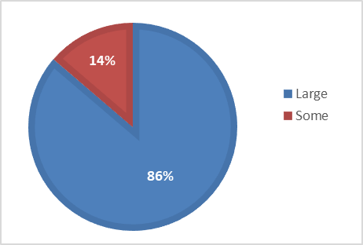
Figure 1. Extent of inclusive participation of communities, groups and relevant NGOs in inventorying (n=42) (B8.1)
Community participation in safeguarding was supported by policy frameworks, participative research and inventorying processes and, in many reporting countries, a culture of volunteering and participating in community organizations. Some community organizations are established as non-governmental organizations (NGOs). For example, in Hungary, the Muharay Elemér Folk Art Association is a nationwide organization whose members document, teach and perform folk dance, music and costume traditions of their own communities.
In most reporting countries, the participation of minorities and/or indigenous peoples in safeguarding of their intangible cultural heritage received specific attention. This will be discussed further below.

International and regional cooperation for safeguarding
Reporting countries have engaged extensively with the various international mechanisms of the Convention. In this cycle (i.e. up to but not including inscriptions at 16.COM (2021)), reporting countries had nominated 11 elements inscribed on the Urgent Safeguarding List, 177 elements inscribed on the Representative List and 16 Programmes selected for the Register of Good Safeguarding Practices. Multinational nominations have been a major tool in encouraging international cooperation for safeguarding specific elements among reporting countries and internationally, with 28 multinational inscriptions on the Representative List and one multinational programme on the Register of Good Safeguarding Practices. The inscriptions “Art of dry stone walling” and “Mediterranean diet”, involved seven or more reporting countries. Seven projects were financed through International Assistance (the Intangible Cultural Heritage Fund), benefiting four of the reporting countries: Albania, Armenia, Belarus and Latvia. Most of these projects concerned documentation and inventorying. Albania received International Assistance for three projects, including two inventorying projects, an inventory of “Albanian folk iso-polyphony” (2011-12) and a community-based inventory of intangible cultural heritage in Albania (2020-22).
Most countries reported high levels of international cooperation on intangible cultural heritage safeguarding in general, and in regard to specific elements of intangible cultural heritage (B24.1 and B24.2). Much of this cooperation was at the regional level. Regional cooperation between countries reporting in this cycle and their neighbours has been facilitated by the presence of a number of different multilateral organizations and frameworks in Europe and Central Asia. These include the Commonwealth of Independent States (CIS), the Council of Europe, the European Union (EU), the Nordic Council of Ministers and the International Organization of Turkic Culture (TURKSOY). Such organizations and frameworks have supported cooperation in the field of intangible cultural heritage by setting policy priorities, establishing programmes for heritage days, cultural capitals, cultural routes and supporting various funding schemes.
Expert networks of practitioners, academics, including UNESCO Chairs, and accredited NGOs have also made a significant contribution international cooperation between reporting countries for intangible cultural heritage safeguarding and management. Category 2 Centres on intangible cultural heritage have played an important role in fostering international cooperation by reporting countries, in particular the Regional Centre for the Safeguarding of the Intangible Cultural Heritage in South-Eastern Europe under the auspices of UNESCO , based in Sofia, Bulgaria. A large number of accredited NGOs (98 in all) were based in countries reporting in this cycle, representing about half of all NGOs accredited under the Convention by 2021. Some of these NGOs have regional or international mandates. The International Council for Traditional Music (ICTM), for example, based in Austria, supports safeguarding of traditional music and dance internationally.

Digital tools for safeguarding
Countries reporting in this cycle provided evidence of the important role played by digital tools in implementation of the Convention. Digital platforms have allowed broader and more cost-effective information sharing and collaboration, especially where internet access was made widely available, and where provisions were made for users with disabilities. In Italy, the Fondazione ISMU (Initiatives and Studies on Multiethnicity) created an on-line resource Heritage and Interculture to support cultural heritage professionals promoting intercultural engagement in Italian museums and heritage institutions. The use of digital tools for safeguarding increased during the COVID-19 pandemic (discussed in the following section).
Reporting countries frequently provided online access to intangible cultural heritage inventories and related research data; some have had policies and programmes supporting this for many years. In France, an ICH lab database, data visualization and relational mapping, and an aggregator site for data from multiple different sources, has been developed to provide public access to inventoried elements and assist in data analysis. Specific access to digitized collections has been provided for Wayana and Apalai communities in French Guiana through the SAWA project and its digital portal (WATAU). Various reports acknowledged the importance of considering issues such as community consent, mutual respect and intellectual property rights in the provision of digital access to intangible cultural heritage-related information. In 2017-2018, the Martynas Mazvydas National Library of Lithuania created an interactive tool on the labelling of digital content and a guideline about the use of folklore and derivative works.
Digital access has promoted greater community involvement in inventorying, especially with the use of easily updated wiki inventories, search tools, multimedia information and social media links. In Switzerland, the online prevention platform White Risk, run by the bearers of the element "Avalanche Risk Management”, has been used both for awareness raising and training in avalanche risk management, particularly in the field of snow-sport. Creation of online repositories of intangible cultural heritage-related information have allowed for greater synergies with environmental and tangible heritage planning, for example in Slovakia, where the Slovak Cultural Heritage Web Portal incorporates information on both tangible and intangible cultural heritage.

Challenges and opportunities

The impact of the COVID-19 pandemic
The COVID-19 pandemic, from March 2020 onwards, affected both the practice of intangible cultural heritage and safeguarding activities in reporting countries. While some home-based activities, such as knitting, manual trades, crafts and cooking traditional foods, became more popular and thus supported intangible cultural heritage safeguarding, many festivals, gatherings, education and safeguarding activities were reduced, suspended or changed. In Türkiye, most of the large Hidrellez Spring celebrations were cancelled in 2020 and practitioners celebrated it at their homes with close family members and via organized events on social media. Some countries provided special funding to address intangible cultural heritage endangerment associated with the COVID-19 pandemic. In 2020, for example, some German states provided compensation to community associations or practitioners affected by financial hardship caused by the pandemic.
Many forms of intangible cultural heritage practice, transmission and awareness raising were able to adapt fairly quickly to pandemic restrictions by moving online. Communities created or expanded social media forums for transmission of their intangible cultural heritage during the pandemic. The pan-Armenian flash mob "Come and Dance Kochari", performing a traditional dance, was held online in 2020. The Ethnographic Museum in Zagreb used its online educational platform “Museum from the Couch” to provide information about Croatian Representative List inscriptions to primary and secondary school students, families and the elderly. Increased use of digital tools such as these has continued to promote new ways of participation and more diverse audiences in some contexts. In Romania, an online platform was created for inventorying and selling traditional crafts; young people created newsletters about rural culture and a platform for raising awareness about it through 3D museum tours.
The longer-term impact of the pandemic on the viability of some intangible cultural heritage elements remains uncertain. Practitioner numbers have decreased in some cases; tourism economies and other sources of income remain badly affected. Studies were done in several countries in order to assess the impact of the pandemic on intangible cultural heritage practice and transmission, and on the cultural or creative industry sectors. The study “Impact of the COVID-19 Pandemic on the Cultural Sector” conducted by the Latvian Academy of Culture in 2020, for example, showed that cultural consumption decreased significantly during the pandemic and that this affected intangible cultural heritage practitioners.

Safeguarding in a context of cultural diversity
The countries in this reporting cycle are culturally and linguistically diverse. Thus, it is not surprising that almost all countries involved people of different ethnic groups in safeguarding plans; three fifths of reporting countries said that intangible cultural heritage safeguarding plans involved migrants and refugees (B16.1). Migration is a common phenomenon across reporting countries and some countries have large diaspora communities living abroad. Travelling was (or is) a way of life for certain communities and groups, including the Roma, Romani or Traveller communities, who sometimes still experience discrimination. Conflict, climate change and economic hardship have also led to movements of people into and between reporting countries, whether as economic migrants or refugees.
Various policies and programmes supported cultural and linguistic diversity in intangible cultural heritage safeguarding, and addressed racism or discrimination. In primary and secondary education settings, all countries reported that students learned to respect and reflect on the intangible cultural heritage of their own community and others through educational programmes and curricula (B5.2). Intangible cultural heritage was included in the curriculum via mother-tongue education, multilingual education and local content in almost all countries (B5.3, B6.1, B12.3). For example, in Serbia, members of national minorities have the right to mother-tongue education in eight different languages at preschool, primary and secondary levels, depending on local enrolment numbers.

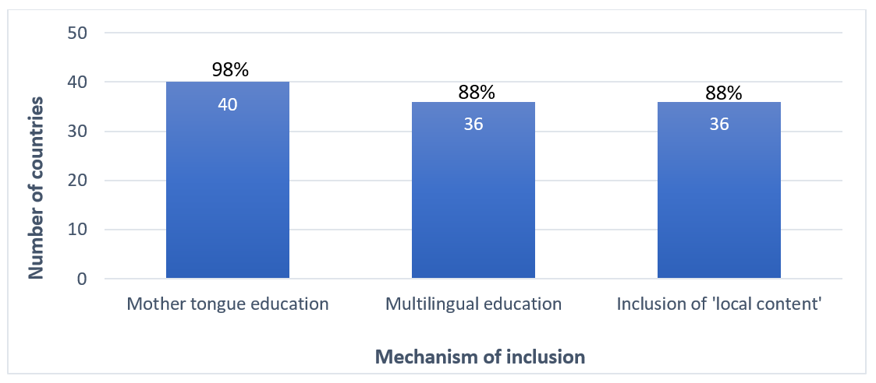
Figure 2. Mechanisms for inclusion of intangible cultural heritage in primary and secondary education curricula in reporting countries (n=41) (B5.3)

Other institutions than schools also support multilingualism. The Vigdís International Centre for Multilingualism and Intercultural Understanding in Iceland, for example, promotes multilingualism, research into mother-tongue language access as a human right and awareness-raising about the importance of language as a core element of the cultural heritage of humanity.

Balancing safeguarding, environmental conservation and human rights

The Convention only takes intangible cultural heritage into account that is “compatible with existing international human rights instruments, as well as with the requirements of mutual respect among communities, groups and individuals, and of sustainable development” (article 2.1). Most countries reported that communities, groups and individuals used their intangible cultural heritage for dialogue promoting mutual respect, conflict resolution and peace-building (B15.2), and that safeguarding promoted mutual respect (B16.2). Development interventions in over four fifths of countries recognized intangible cultural heritage as a resource for sustainable development (B15.3). In some cases, however, the reports suggested the need for further dialogue on certain intangible cultural heritage practices and how they relate to questions of human rights and environmental management.
Several reports noted the existence of community disputes around the compatibility of some intangible cultural heritage practices with human rights and mutual respect. Strategies for addressing this included supporting community dialogue and mediation, as well as developing guidelines and policies in line with human rights legislation. Ireland’s “Vision, Mission and Principles for Intangible Cultural Heritage”, for example, includes the principle that “Recognition of intangible cultural heritage practices is based on a policy of respect, inclusivity and diversity”. Under the project “Heritage in motion”, the Dutch Centre for Intangible Cultural Heritage (KIEN, the Netherlands) facilitated community and public dialogue in the debate on St Nicholas and Zwarte Piet, his blackface helpers, using the documentary “White is a colour too” (2016) to present different perspectives on the controversy.
Intangible cultural heritage practice frequently assists in environmental management, but community norms regarding the management of agriculture, forests and access to wild foraging, fisheries or water resources may sometimes be in tension with current laws on environmental conservation and private property rights. In Sweden’s report, Sámi stakeholders emphasized that dissemination of knowledge about their intangible cultural heritage could highlight alternative approaches to the use of natural resources, and assist in dialogue to resolve such tensions. Just over two thirds of reporting countries said that their policies recognized the importance of protecting the customary rights of communities and groups to ecosystems necessary for the practice and transmission of intangible cultural heritage (B14.2).

Priority areas
The reports indicated some trends in regard to intangible cultural heritage safeguarding activities that relate to UNESCO priority areas on indigenous peoples, youth and gender equality. Most countries reported the involvement of people of different genders, ethnic identities and ages in intangible cultural heritage safeguarding plans and programmes (B16.1). Four fifths of the countries reported the involvement of people with disabilities. About three fifths of the countries reported inclusivity of members of vulnerable groups and migrants, immigrants or refugees in intangible cultural heritage safeguarding plans and programmes. Only about a third reported the involvement of indigenous peoples in these plans and programmes; this was partly because most countries did not report about any indigenous peoples in their territory.

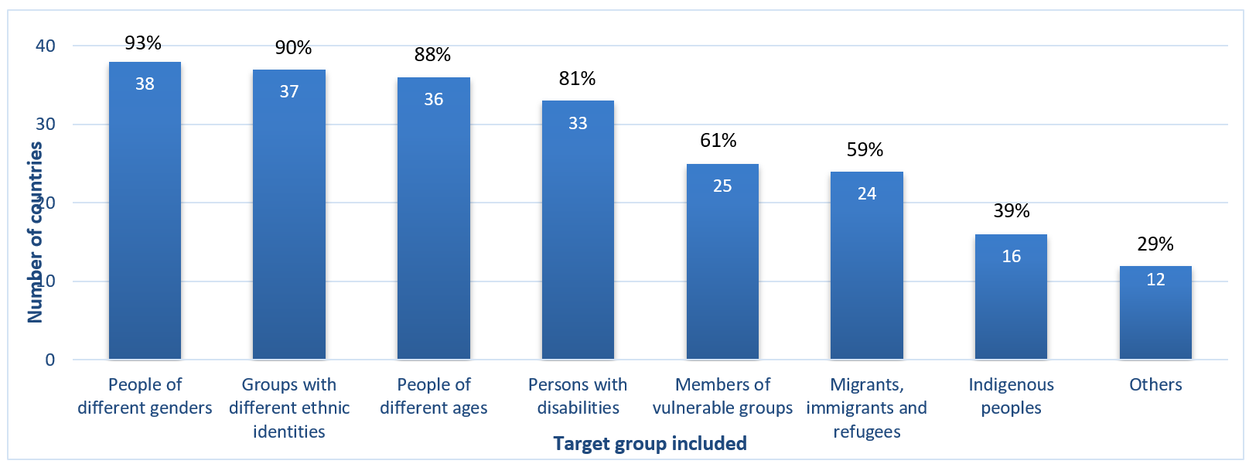
Figure 3. Inclusivity of intangible cultural heritage safeguarding plans and programmes in reporting countries, by target group (n=41) (B16.1)

Indigenous peoples
In some countries, significant attention was paid to supporting indigenous peoples in safeguarding their intangible cultural heritage. Indigenous peoples specifically mentioned in the reports included, among others, the Greenland Kalaallit or Inuit (Denmark), the Livonian people (Latvia) and the Sámi (Norway, Finland and Sweden). Some of the indigenous peoples mentioned in the reports have worked closely with international indigenous forums, such as the Inuit Circumpolar Council (ICC). Latvia has actively participated in the work of the United Nations Group of Experts on Geographical Names (UNGEGN), providing information on Livonian toponyms through the Livonian Institute of the University of Latvia.
Different kinds of policy mechanisms support the safeguarding of indigenous cultural heritage. The Sámi Parliaments in Finland, Norway and Sweden have worked with the Saami Council, a community-based NGO, to coordinate work with Sámi intangible cultural heritage across Sápmi (the land of the Sámi). In Greenland (Denmark), most of the population is indigenous Kalaallit, and the safeguarding of their culture (including intangible cultural heritage) has been a focus of their country’s policies and programmes.

Youth
Youth engagement in intangible cultural heritage safeguarding in the reporting countries received considerable attention in the reports. Ten reporting countries were involved in a joint project with UNESCO and the European Commission entitled “Engaging Youth for an Inclusive and Sustainable Europe”, in the context of the European Year of Cultural Heritage (EYCH2018), aimed at encouraging and stimulating young people to explore their cultural heritage and actively participate in its safeguarding and transmission.
Primary and secondary school curricula incorporated intangible cultural heritage as a way of teaching other subjects in four fifths of reporting countries (B5.1). All countries reported that communities, NGOs and heritage institutions were actively involved in formal or non-formal intangible cultural heritage education programmes (B4.1), some of which were aimed at young people. In Bosnia and Herzegovina, for example, the project "Cultural Heritage - the Future of Youth", led by the Association "Sahan" and supported by the Ministry of Science, Higher Education and Youth, ran workshops on embroidery and wool felting, and staged a fashion show with people of different ages wearing folk costumes.
Many reports noted that the future viability of intangible cultural heritage elements was threatened by reduced youth interest. This challenge can be related to other threats frequently mentioned in the reports (A6.m), such as low practitioner incomes, changing uses of leisure time, problems accessing materials and spaces for intangible cultural heritage practice, urbanization and, in some cases, increased concern among young people about the environmental sustainability of intangible cultural heritage practices. Addressing reduced youth interest in intangible cultural heritage may thus require going beyond the provision of information and encouragement to young people, to develop a broader systematic approach addressing questions of incentives and livelihoods. In Finland, for example, the Arts Promotion Centre (Taike) implemented a cultural development programme for children and young people (2016–2020). This aimed to encourage professional artists working with children and youth, promote employment and promote activities in under-served areas.

Gender equality
Reporting countries demonstrated strong policy priorities around gender equity and inclusion in general, and noted increasing gender sensitivity on the part of various stakeholders engaged in intangible cultural heritage safeguarding. Some intangible cultural heritage practices do remain gender-specific, but social activism, threats to the viability of some traditions, or changes in social norms, have also resulted in greater gender inclusivity over time. Belarus reported, for example, that men have recently started doing more weaving, embroidery and straw plaiting, previously mainly practised by women. The Norwegian government helped to broaden ideas of gender diversity within intangible cultural heritage by declaring 2022 a “Year of Queer Culture”, and making funding available to highlight this issue.
A number of reports acknowledged that further progress on gender inclusivity and equality was needed, and gave examples of strategies that could be adopted to achieve this. In Spain, for example, regional and national policies have emphasized the need to prevent violence against women during festivals and other intangible cultural heritage activities. The Gabeiras Foundation’s project “Intangible Heritage and Gender” did research on gender inequalities in participation at festivals and made recommendations on how to address them, for example by taking steps to reduce harassment of women at the gatherings, including designating “safe areas” and providing training to reduce the risk of violence.

Contributions to sustainable development
The current United Nations (UN) framework for sustainable development is Agenda 2030, monitored through 17 Sustainable Development Goals (SDGs). UNESCO’s Culture 2030 framework assists culture sector actors in linking their work to Agenda 2030. The high level Overall Results Framework for the 2003 Convention includes the contribution of safeguarding activities to sustainable development as one of the impacts of implementing the Convention. The Operational Directives’ Chapter VI contains guidance for States Parties on encouraging synergy between intangible cultural heritage safeguarding and sustainable development objectives.
Within the framework of these initiatives, many reporting countries prioritized sustainable development in policies and programs across different sectors, including culture. For example, Romania’s Sustainable Development Strategy 2030, drafted in 2018 as the national strategy for implementing the UN Agenda 2030, acknowledged the positive impact of traditional small-scale farming based on ecological principles on the national agricultural system and food security. It also aimed to support the use of traditional knowledge on medicinal plants and forest fruits. In the context of the Framework Convention on the Protection and Sustainable Development of the Carpathians, Czechia, Poland, Romania, Serbia, Slovakia, Ukraine and Hungary have promoted the link between sustainable development and intangible cultural heritage safeguarding. Several international projects on intangible cultural heritage and sustainable development have been initiated. These included the LIVIND project involving nine countries in the Northern Dimension region, the Atlantic CultureScape project involving Spain, Portugal, Ireland and the United Kingdom, and the LIVHES project involving Spain, France, Portugal and Andorra.
The reports provided some evidence demonstrating the contributions of safeguarding activities to sustainable development. The examples below have been organized according to the themes outlined in the Operational Directives: inclusive social development, inclusive economic development, environmental sustainability, and social cohesion and peace.
In regard to inclusive social development, many countries reported how the implementation of the Convention led to a wider range of social groups becoming involved in intangible cultural heritage practices. In Greece, for example, the “Amoli” (furrow) project in the multicultural town of Aspropyrgos, near Athens, used art and walking routes to explore intangible cultural heritage such as agricultural and food traditions as a shared experience of diverse local communities, including several Greek communities, Roma and groups recently arrived from India and Romania. This project challenged stereotypes and promoted social cohesion, helping to realize SDG Target 10.2 on social, economic and political inclusion. As mentioned above, many reports demonstrated that women have been participating in and leading intangible cultural heritage activities to a greater extent in this reporting cycle, thus furthering SDG Targets 5.5 and 5.a on equal representation in leadership and equal rights and access to economic resources. Some activities, such as the Gabeiras Foundation project cited above, also furthered SDG Target 5.2 on the elimination of violence against women.
In regard to inclusive economic development, many projects mentioned teaching intangible cultural heritage-related skills in local communities to promote livelihoods, for example a project in the area of Pakirsinis in Lithuania provided training in heritage food preparation and blacksmithing to socially excluded or unemployed youth and adults, fostering community cooperation and earning potential (SDG Target 8.6). Several countries also mentioned projects transmitting intangible cultural heritage-related skills to people with disabilities. The Sheki Disabled People Care Association in Azerbaijan, for example, taught craft skills to people with disabilities so they could earn money making souvenirs for tourists. Such projects contributed to several SDG Targets for Goal 4 on education and training, as well as SDG Target 10.2 on inclusion.
In regard to environmental sustainability, reporting countries were well aware that culture and environmental issues are intertwined so that safeguarding intangible cultural heritage also means maintaining and reinvigorating ecosystems. For example, in Estonia, encouraging sustainable local farming practices based on traditional grazing knowledge helped to restore alvar grasslands (thinly soiled limestone plateaux) in the LIFE+ project (2014-19), thereby supporting the realization of SDG Target 15.1. In Belgium, the “Molen je mee” (Windmill your way) programme at the Arbeid Adelt mill in Weelde created opportunities for schoolchildren to visit windmills and learn about both sustainable agriculture and renewable energy through the lens of the miller’s craft (SDG Target 4.7).
In regard to social cohesion and peace, countries have used intangible heritage for resolving local disputes or to bring together different groups in the local community. Romania, for example, supported intangible cultural heritage activities in the fishing villages of Mila 23 in the Danube delta, inhabited by people of Lipovan, Russian and Ukrainian descent. Sustaining tangible and intangible heritage in these communities helped both maintain a common identity and manage the wetland environment. Such projects supported SDG Target 16.7 on participatory decision making.
Thematic areas

Thematic area I - Institutional Capacities
To assist in implementing the Convention and intangible cultural heritage safeguarding, the Convention strongly recommends in Article 13(b) that State Parties “designate or establish one or more competent bodies for the safeguarding of the intangible cultural heritage present in [their] territory”. Some bodies have functions relating to intangible cultural heritage in general (see OD 154(a)), others are focused on specific intangible cultural heritage elements (see ODs 158(a) and 163(a)). States are encouraged to establish consultative bodies or coordination mechanisms to promote the involvement of communities and other stakeholders in intangible cultural heritage safeguarding, in line with Article 15 and OD 80. The Convention also encourages States Parties to support other institutions such as cultural centres, centres of expertise, research and documentation institutions, museums, archives and libraries that can contribute to intangible cultural heritage safeguarding (ODs 80 and 109, Article 13(d)(iii)).
The Periodic Report thus contains a number of questions about competent bodies and other institutions that support intangible cultural heritage safeguarding at the national or local level. These are as follows:

List of core indicators and assessment factors on institutional capacities (B1)
Core Indicators | Assessment According to the Following
B1. Extent to which competent bodies and institutions and consultative mechanisms support the continued practice and transmission of intangible cultural heritage | - One or more competent bodies for intangible cultural heritage safeguarding have been designated or established.
 | - Competent bodies exist for safeguarding specific elements of intangible cultural heritage, whether or not inscribed.
 | - Broad and inclusive involvement in intangible cultural heritage safeguarding and management, particularly by the communities, groups and individuals concerned, is fostered through consultative bodies or other coordination mechanisms.
 | - Institutions, organizations and/or initiatives for intangible cultural heritage documentation are fostered, and their materials are utilized to support continued practice and transmission of intangible cultural heritage.
 | - Cultural centres, centres of expertise, research institutions, museums, archives, libraries, etc., contribute to intangible cultural heritage safeguarding and management.

Summary of analytical findings
Across all of the reporting countries, a total of 160 competent bodies have been established for intangible cultural heritage safeguarding, at least one in each country (B1.1). Countries with federal systems of governance tended to have multiple such bodies. Overall, 25 of the reporting countries had more than one competent body. Competent bodies were often located in governmental institutions, such as ministries responsible for culture, as in the case of Albania, where the competent body, the National Center of Traditional Activities, is one of the subordinate institutions of the Ministry of Culture. In some countries, key responsibilities for the implementation of the Convention (such as inventorying) were allocated to NGOs or other institutions. Such institutions included the Dutch Centre for Intangible Cultural Heritage (KIEN) in the Netherlands, the Estonian Centre of Folk Culture (Estonia) and the Centre for the Intangible Cultural Heritage of Serbia at the Ethnographic Museum in Belgrade. In three quarters of countries, competent bodies were also established for safeguarding specific intangible cultural heritage elements or domains (B1.2). Countries reported 184 such bodies, although this number is likely an underestimate as bodies established at sub-national levels were not routinely included in the reports.
Consultative bodies or coordination mechanisms for supporting the continued practice and transmission of intangible cultural heritage, including advisory or consultative bodies and networks, have been established in almost all countries (B1.3). In Finland, multistakeholder networks called “Circles of Living Heritage”, involving practitioners as well as NGOs, museums and other organizations to support the implementation of the Convention and to share good practices, have been set up across the country for most intangible cultural heritage domains. Local intangible cultural heritage boards with academic and community representation have been established in 81 provinces of Türkiye for the preparation and updating of the necessary forms regarding inscriptions on the National Inventory of Intangible Cultural Heritage and the Living Human Treasures Inventory.
Reporting countries have made substantial long-term investments in institutions, organizations and/or initiatives for documenting intangible cultural heritage (B1.4). For example, the Audiovisual Institute of Monaco has an archive of over 15,000 films, documentaries, reports, advertisements, radio broadcasts, recordings of shows and festivals as well as family and amateur films. Documentation of this kind was used in most countries for raising awareness about intangible cultural heritage and its practitioners, enabling appropriate access to information and developing educational and training material. It was also used to identify current or future threats concerning the viability of intangible cultural heritage elements and to develop appropriate safeguarding measures. As mentioned above, much of the documentation has been made available digitally.
Overall, almost all of the countries reported that museums and research institutions contributed towards intangible cultural heritage safeguarding and management, alongside archives and cultural centres (B1.5). The role of museums was particularly highlighted in the reports. In Andorra, for instance, the Museus network of national and private museums worked together on the promotion of Andorran culture and organized complementary activities, such as school visits, discussions and games, in order to promoted public access to their cultural heritage. Just under three quarters of reporting countries emphasized the role of centres of expertise for the safeguarding and management of intangible cultural heritage (B1.5). For example, the institution “National Costume Rental and Manufacture” in Zagreb, Croatia, has contributed to the safeguarding of knowledge and skills associated with traditional clothing by maintaining and restoring collections and co-organizing events with other organizations, including exhibitions, seminars, workshops and shows.

Figure 4: Contribution of different kinds of institutions towards intangible cultural heritage safeguarding and management in reporting countries (n=42) (B1.5)
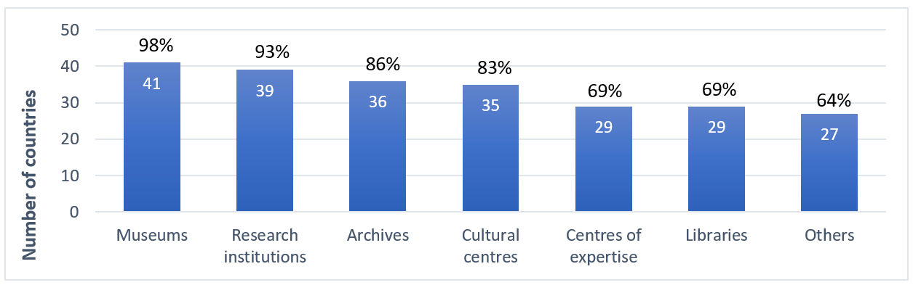

Eighty six percent of reporting countries fully satisfied the core indicator B1 at the baseline, i.e. the extent to which competent bodies and consultative mechanisms support the continued practice and transmission of intangible cultural heritage.

The significant and continuing investment in competent and consultative bodies as well as in coordinating mechanisms for safeguarding implies that these institutions and organisations were considered to be effective mechanisms for implementing the Convention by reporting States.

Thematic areas I and II - Education, building human capacities and transmission
In the Convention, education is given a prominent place among a State’s safeguarding responsibilities at the national level. Article 14(a)(i) stresses the importance of educational programmes aimed at the general public, and youth in particular, while Article 14(a)(ii) concerns educational programmes within the communities and groups concerned. The relevance of non-formal means of transmitting knowledge is emphasized in Article 14(a)(iv). Education can raise awareness and strengthen transmission mechanisms for intangible cultural heritage, especially where communities, groups and individuals concerned are involved in designing and delivering educational programmes, in line with Article 15, which refers to their “widest possible participation” in safeguarding activities. The principles of inclusiveness and non-discrimination are fundamental values of the United Nations, as of UNESCO, and are reiterated in the Operational Directives and Ethical Principles.
The Periodic Report thus contains a number of questions about how intangible cultural heritage is included in educational programmes and curricula, how communities and bearers of intangible cultural heritage (and other stakeholders) are involved in these efforts, and what the impact of these initiatives is on intangible cultural heritage safeguarding. These questions, under Thematic Areas I and II, are as follows:

List of core indicators and assessment factors on education, building human capacities and transmission (B2-B6)
Core Indicators | Assessment According to the Following
B2. Extent to which programmes support the strengthening of human capacities to promote safeguarding and management of intangible cultural heritage | - Tertiary education institutions offer curricula and degrees in intangible cultural heritage safeguarding and management, on an inclusive basis.
 | - Governmental institutions, centres and other bodies provide training in intangible cultural heritage safeguarding and management, on an inclusive basis.
 | - Community-based or NGO-based initiatives provide training in intangible cultural heritage safeguarding and management, on an inclusive basis.
B3. Extent to which training is operated by or addressed to communities, groups and individuals, as well as to those working in the fields of culture and heritage | - Training programmes, including those operated by communities themselves, provide capacity building in intangible cultural heritage addressed on an inclusive basis to communities, groups and individuals.
 | - Training programmes provide capacity building in intangible cultural heritage addressed on an inclusive basis to those working in the fields of culture and heritage.
B4 Extent to which both formal and non-formal education strengthen the transmission of intangible cultural heritage and promote respect for intangible cultural heritage | - Practitioners and bearers are involved inclusively in the design and development of intangible cultural heritage education programmes and/or in actively presenting and transmitting their heritage.
 | - Modes and methods of transmitting intangible cultural heritage that are recognized by communities, groups and individuals are learned and/or strengthened, and included in educational programmes, both formal and non-formal.
 | - Educational programmes and/or extra-curricular activities concerning intangible cultural heritage and strengthening its transmission, undertaken by communities, groups, NGOs or heritage institutions, are available and supported.
 | - Teacher training programmes and programmes for training providers of non-formal education include approaches to integrating intangible cultural heritage and its safeguarding into education.
B5. Extent to which intangible cultural heritage and its safeguarding are integrated into primary and secondary education, included in the content of relevant disciplines, and used to strengthen teaching and learning about and with intangible cultural heritage and respect for one’s own and others’ intangible cultural heritage | - Intangible cultural heritage, in its diversity, is included in the content of relevant disciplines, as a contribution in its own right and/or as a means of explaining or demonstrating other subjects.
 | - School students learn to respect and reflect on the intangible cultural heritage of their own community or group as well as the intangible cultural heritage of others through educational programmes and curricula.
 | - The diversity of learners’ intangible cultural heritage is reflected through mother tongue or multilingual education and/or the inclusion of ‘local content’ within the educational curriculum.
 | - Educational programmes teach about the protection of natural and cultural spaces and places of memory whose existence is necessary for expressing intangible cultural heritage.
B6. Extent to which post-secondary education supports the practice and transmission of intangible cultural heritage as well as study of its social, cultural and other dimensions | - Post-secondary education institutions offer curricula and degrees (in fields such as music, arts, crafts, technical and vocational education and training, etc.) that strengthen the practice and transmission of intangible cultural heritage.
 | - Post-secondary education institutions offer curricula and degrees for the study of intangible cultural heritage and its social, cultural and other dimensions.

Summary of analytical findings
Almost all of the countries reported that formal and non-formal educational programmes strengthened the transmission of intangible cultural heritage during this reporting cycle (B4, B4.2). A variety of educational approaches were mentioned including formal curricula, online open-access education, informal workshops and camps, amateur clubs, festivals, exhibitions and competitions. Volunteers have been very important in supporting extra-curricular programming, supported by organizations such as museums and NGOs. The Macedonian Research Society-MID (North Macedonia), for example, was accredited as an NGO under the Convention in 2012. Its members have done field research and maintained an extensive inventory about North Macedonian knowledge and practices concerning nature and the universe (including ethno-astronomy and weather knowledge), collected since 1982. This information has been used for education and safeguarding purposes.
Intangible cultural heritage and its safeguarding has received increasing attention in formal education, enabled through a strong emphasis on multilingual and mother-tongue education in a culturally diverse context, as mentioned above (B5.3). School curricula in about four fifths of reporting countries accommodated intangible cultural heritage-related content as a means of explaining or demonstrating other subjects. Only about three fifths of countries included it as a stand-alone subject (B5.1). Digital tools have been increasingly useful in this regard. Armenia, young people from the programming centre "Annaniks" developed "Sasunci Davit", a digital application for Android and IOS systems based on the themes of the epic poem David of Sassoun. From 2018, the application was used in the school curriculum as a resource for teaching the epic.
Many reports emphasized the flexibility of educational curricula, allowing schools and teachers to design their lessons to serve local needs. For this reason, teacher training, interest and engagement with practitioners affected how intangible cultural heritage was integrated into formal education, alongside the visibility of intangible cultural heritage elements at the local level. Most reporting countries offered teacher training programmes and programmes for training providers of non-formal education, which included methods for integrating intangible cultural heritage and its safeguarding into education (B4.4). For example, under the “Heritage in Schools” scheme in Ireland, an initiative of the Irish Heritage Council, teachers in primary schools were provided with online resources to link intangible cultural heritage content to curriculum subjects. The pilot project "Teaching and Learning with Living Heritage in European Schools", part of the project Engaging Youth for an Inclusive and Sustainable Europe, mentioned above, involved teachers in creating new approaches to intangible cultural heritage inclusion in education. The project created a resource kit for teachers that has already been used in several reporting countries.
At the post-secondary level, countries reported significant levels of training contributing to the practice and transmission of intangible cultural heritage (B6.1). Almost all countries reported specific post-secondary educational programmes strengthening the practice and transmission of intangible cultural heritage in the fields of music, arts and craft. Such programmes included well-established systems of professional training and non-formal programmes for adults, in the context of life-long learning. The College for Arts, Science and Technology in Malta, for example, offered a diploma course in masonry heritage skills, leading to careers in stone restoration.

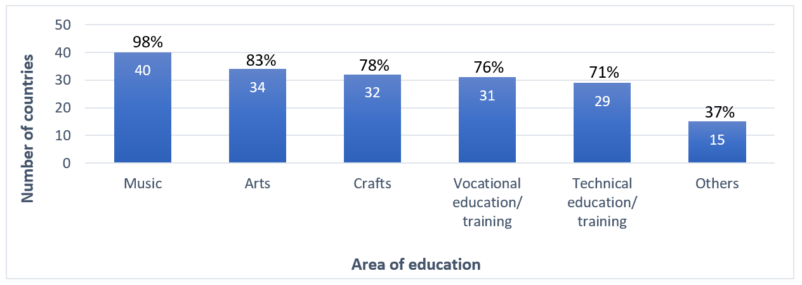
Figure 5: Educational programmes at the post-secondary level in specific subject areas strengthening the practice and transmission of intangible cultural heritage in reporting countries (n=41). (B6.1)

At the tertiary level, programmes supporting the strengthening of human capacities to promote safeguarding and management of intangible cultural heritage were offered in almost all countries (B2.1). As mentioned above, this was supported by the appointment of UNESCO Chairs with mandates relating to intangible cultural heritage. France reported that training in intangible cultural heritage safeguarding had increased significantly since the previous report and was, by the end of this reporting cycle, provided through dedicated courses at 13 universities.
Governmental institutions, centres and other bodies as well as community- and/or NGO-based initiatives offered training on intangible cultural heritage safeguarding and management in almost all countries (B2.2 and B2.3). The Icelandic Lighthouse Society (Icelandic Coastal Culture) and Herring Era Museum, for example, worked with boatbuilders to develop courses in clinker boat building in Iceland. In Luxembourg, the "Naturparkschoul", an informal educational institution run by three nature parks, has offered training courses and educational tools on intangible cultural heritage related to nature, such as the cultivation of orchards.
All the countries reported that educational programmes in intangible cultural heritage safeguarding and management were inclusive (B2.1 and B2.2), generally due to existing equality, diversity and inclusion policies of training providers. In some reports, inclusion was linked to the participation of communities in the design and implementation of educational programmes. A number of reporting countries implemented strategies to increase diversity, for example, by actively approaching underrepresented groups, using the language and communication channels of specific target groups and/or offering training at a reduced cost. Online and open access mechanisms were also mentioned as ways of making programmes more inclusive.
Over four fifths of reporting countries fully satisfied the core indicators B2 and B3 at the baseline, on the extent to which programmes support the strengthening of human capacities to promote safeguarding and management of intangible cultural heritage, and are operated by or addressed to communities, groups and individuals, as well as to those working in the fields of culture and heritage respectively. More than four fifths of reporting countries also fully satisfied the core indicator B4, relating to formal and non-formal educational programmes strengthening the transmission of intangible cultural heritage and promoting respect for intangible cultural heritage respectively. Less than half of the countries fully satisfied core indicator B5 at the baseline on the extent to which intangible cultural heritage and its safeguarding are integrated into primary and secondary education, but most of the remaining countries largely satisfied the indicator at the baseline. About two thirds of countries fully satisfied the core indicator B6 at the baseline, relating to the role of post-secondary education in intangible cultural heritage safeguarding.
The reports demonstrate a significant and rising number of educational programmes and professional training opportunities supporting intangible cultural heritage safeguarding. Ongoing teacher training is needed to sustain and extend this trend in formal primary and secondary education; the reports offer some good practices in this regard. Further attention might be paid to ways of supporting community volunteers and NGOs working on non-formal education programmes.

Thematic area III - Inventories
In Article 11(b), the Convention requires that a State Party “identify and define the various elements of the intangible cultural heritage present in its territory, with the participation of communities, groups and relevant non-governmental organizations”. Article 12.1 specifies that the purpose of inventorying is “To ensure identification with a view to safeguarding”. It indicates that each State Party “shall draw up, in a manner geared to its own situation, one or more inventories of the intangible cultural heritage present in its territory. These inventories shall be regularly updated.” The Convention encourages States Parties to endeavour to ensure access to information about the intangible cultural heritage in such inventories, while respecting customary practices governing such access (Article 13(d)(ii)). In order for elements to be inscribed on one of the Lists of the Convention, they need to be included on an inventory of intangible cultural heritage.
The Periodic Report contains a number of questions about the design and format of inventories of intangible cultural heritage, how communities, groups and individuals and other stakeholders participate in inventorying and how inventories contribute to safeguarding, for example by recording intangible cultural heritage viability or being updated. These are as follows:

List of core indicators and assessment factors on inventories (B7-B8)
Core Indicators | Assessment According to the Following
B7. Extent to which inventories reflect the diversity of intangible cultural heritage and contribute to safeguarding | - One or more inventorying systems oriented towards safeguarding and reflecting the diversity of intangible cultural heritage have been established or revised since ratification.
 | - Specialized inventories and/or inventories of various scopes reflect diversity and contribute to safeguarding.
 | - Existing inventory or inventories have been updated during the reporting period, in particular to reflect the current viability of elements included.
 | - Access to intangible cultural heritage inventories is facilitated, while respecting customary practices governing access to specific aspects of intangible cultural heritage, and they are utilized to strengthen safeguarding.
B8. Extent to which the inventorying process is inclusive, respects the diversity of intangible cultural heritage and its practitioners, and supports safeguarding by communities, groups and individuals concerned | - Communities, groups and relevant NGOs participate inclusively in inventorying which informs and strengthens their safeguarding efforts.
 | - Inventorying process respects the diversity of intangible cultural heritage and its practitioners, including the practices and expressions of all sectors of society, all genders and all regions.

Summary of analytical findings
A total of 113 inventories of intangible cultural heritage were reported on by countries in this cycle (A6). All of the countries reported on at least one intangible cultural heritage inventory in their territory, with one third reporting on more than one such inventory. Only two countries (Spain and Czechia) reported more than ten. Many countries reported on both national inventories and sub-national, thematic or specialized inventories. Several trans-border inventories have also been developed as the result of cooperation projects. The inventories contained information about more than 42,000 intangible cultural heritage elements (A6.g), according to the reports; this number is likely an underestimate as the number of elements on every inventory was not reported.
A number of countries included information about bearers and communities concerned as well as intangible cultural heritage elements in their inventories. In most cases, inventorying was the result of a collaborative process including bearers, researchers, national or regional culture institutions, advisory bodies, independent experts, intangible cultural heritage curators, museums, NGOs and even, in one country, specialist private companies. In more than four fifths of countries, communities, groups and relevant NGOs were reported to have participated inclusively in inventorying (B8.1).
Just over two thirds of the countries reported that the inventories fully or largely reflected the diversity of intangible cultural heritage in their territory (B7.1b). This was achieved in various ways. In Belarus, for example, locally-based participatory inventorying processes helped to ensure a proper balance between domains, sub-regions, rural and urban places and ethnic groups in the inventory. In Austria, the nomination form for the national inventory promoted reflection on inclusivity by including a question about whether all genders were included in practice of the proposed element. Migrant groups and minorities identified as under-represented in the national inventory were specifically encouraged and assisted to nominate elements.
Most inventories followed the approach of the Convention, not just in defining intangible cultural heritage, but also in categorizing elements by domain (A6.h). Several inventories included additional domains such as sports, games, foodways, or systems of social organization. Most inventories were organized by domain or sub-region (A6.i). In the Republic of Moldova, the National Intangible Cultural Heritage Inventory was divided into three volumes, two with elements arranged according to cultural or ethnic groups, and the third arranged by domain.
Many inventories relied on additional criteria for inclusion of an element besides the definition of intangible cultural heritage in Article 2.1 of the Convention (A6.j) and evidence of community participation and consent to inventorying. For example, Germany’s criteria for inclusion in the Nationwide Inventory of Intangible Cultural Heritage attached particular importance to an open, inclusive and participative approach to safeguarding. The criteria required applicants to engage in a nuanced reflection on how practices came about historically, how the intangible cultural heritage was embedded in society, evidence of its adaptability and (where applicable) any links with other forms of cultural expression in Germany, Europe and beyond. In Latvia, any proposal for inclusion of an element in the inventory was required to be submitted together with a “sustainable development plan” for the element.
Overall, more than four fifths of the countries stated that inventories in their territory were fully or largely oriented towards safeguarding (B7.1a). Over four fifths of inventories included information about the viability of the element (A6.l) and inventories were almost all regularly updated (A6.e). Three quarters of the inventories included information about threats to the viability of intangible cultural heritage elements (A6.m). Under-remuneration, over-commercialisation, decontextualization, the COVID-19 pandemic, changing lifestyles and migration were mentioned in the reports as common threats to the viability of intangible cultural heritage elements.
Inventories of intangible cultural heritage were used in a number of countries as a repository of local knowledge for development planning (see B15.3). Inventories were also used to raise awareness about intangible cultural heritage, especially where inclusion of an element was followed by a press release and interviews in the national media. In Slovenia, inventorying encouraged cooperation between bearers on exhibitions and events, for example. Inclusion in the inventory was often the basis for State funding and support at the local level.
Most countries reported that the inventories were fully or largely accessible to relevant stakeholders, while respecting customary practices governing access (B7.4a). Online open platforms often ensured access, open consultation and in some cases direct participation. However, some countries reported challenges regarding the accessibility and visibility of inventories. Only about a quarter of the countries reported that inventories were fully utilized for safeguarding (B7.4b).

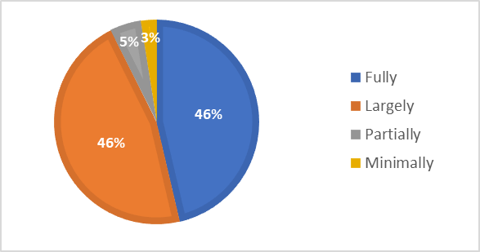
Figure 6. Extent of facilitation of access to inventories in general, respecting customary practices governing access (n=41) (B7.4a)

Only a fifth of the reporting countries fully satisfied the core indicator B7 at the baseline on the extent to which inventories reflect the diversity of intangible cultural heritage and contribute to safeguarding. A further three fifths largely satisfied the indicator. Over four fifths of countries fully satisfied the core indicator B8 at the baseline, on the extent to which the inventorying process is inclusive, respects the diversity of intangible cultural heritage and its practitioners and supports safeguarding.
Across reporting countries, the process of inventorying was diverse, but broadly in line with the principles of the Convention, being participatory and largely oriented to safeguarding. The reports indicated that active steps may be needed to ensure that inventories reflect the diversity of intangible cultural heritage in a country. Ensuring that inventorying contributed effectively to safeguarding of inscribed elements was a challenge in some cases, as was enabling community access for safeguarding purposes.

Thematic area III - Research and Documentation
The Convention encourages States Parties to “foster scientific, technical and artistic studies, as well as research methodologies, with a view to effective safeguarding of the intangible cultural heritage, in particular the intangible cultural heritage in danger” (Article 13(c)). States Parties are also encouraged to adopt appropriate legal, technical, administrative and financial measures aimed at “ensuring access to the intangible cultural heritage while respecting customary practices governing access to specific aspects of such heritage” (Article 13(d)(ii)). Of course, under Article 15 and the Ethical Principles, communities, groups and individuals concerned are central to the safeguarding process, they should be involved in undertaking or guiding research and documentation and be able to use its results.
The Periodic Report thus contains a number of questions about support for research and documentation, community and other stakeholder participation in it, accessibility and utilization. These are as follows:

List of core indicators and assessment factors on research and documentation (B9-B10)
Core Indicators | Assessment According to the Following
B9. Extent to which research and documentation, including scientific, technical and artistic studies, contribute to safeguarding | - Financial and other forms of support foster research, scientific, technical and artistic studies, documentation and archiving, oriented towards safeguarding and carried out in conformity with relevant ethical principles.
 | - Research is fostered concerning approaches towards, and impacts of, safeguarding intangible cultural heritage in general and specific elements of intangible cultural heritage, whether or not inscribed.
 | - Practitioners and bearers of intangible cultural heritage participate in the management, implementation and dissemination of research findings and scientific, technical and artistic studies, all done with their free, prior, sustained and informed consent.
B10. Extent to which research findings and documentation are accessible and are utilized to strengthen policy-making and improve safeguarding | - Documentation and research findings are accessible to communities, groups and individuals, while respecting customary practices governing access to specific aspects of intangible cultural heritage.
 | - The results of research, documentation, and scientific, technical and artistic studies on intangible cultural heritage are utilized to strengthen policy-making across sectors.
 | - The results of research, documentation, and scientific, technical and artistic studies on intangible cultural heritage are utilized to improve safeguarding.

Summary of analytical findings
There was significant support for research or documentation oriented towards safeguarding intangible cultural heritage in reporting countries (B9.2). Research in the field of intangible cultural heritage seems to have been carried out mostly by universities and research centres, followed by archives, libraries, museums, associations or independent researchers. For example, ethnographic research done under the National Archives of Malta’s “Memorja” programme has been made available online, with personal photographs, documents, artifacts and audio-visual material illustrating the life stories of underrepresented groups. In Hungary, research done since the 1950s by the Folk Dance Archive of the Eötvös Loránd Research Network of the Institute of Musicology was made available on an online database and used in educational programming.
Research activities, including those of UNESCO Chairs, were generally financed from State and local government budgets, but intangible cultural heritage-related research in countries in this reporting cycle also benefited from EU funding under Erasmus+, Creative Europe and other programmes (B9.1). The Intangible Cultural Heritage and Museums Project (2017-2020) was, for example, funded under Creative Europe to explore the variety of intangible cultural heritage approaches and practices in museums in Belgium, France, Italy, the Netherlands and Switzerland. Public-private partnerships supporting intangible cultural heritage research funding were quite rare. In 2019, Raiffeisen Bank (Bulgaria) EAD, through a donation campaign called “choose to help”, supported scientific studies on intangible cultural heritage conducted by researchers and community cultural centres. One of the outcomes of these projects was a book of traditional recipes collected by the community of the village of Yuper, Razgrad.
Intangible cultural heritage practitioners and bearers were reportedly involved in the management, implementation and dissemination of research findings and scientific, technical and artistic studies, with their free, prior, sustained and informed consent in almost all countries (B9.3). This was often ensured through research ethics frameworks. Ethical considerations around confidential or sensitive data and protection of intellectual property were also considered when it was disseminated online. In Flanders (Belgium), community representatives used their own logins to update online dossiers about their element and its safeguarding on the ICH Platform. The platform moderator, Workshop Intangible Heritage (WIE), ensured that the principles of free, prior, sustained and informed consent and appropriate involvement of all stakeholders were respected when publications were shared and disseminated.
Participatory research and documentation was used for safeguarding to some extent in most countries, whether in strengthening policy-making or designing safeguarding measures (B10.2, B10.3), although less than a third of the countries reported that this was true to a “high” extent. The Osmose project led by the Institute of Social Sciences of Politics in France and the Latvian Academy of Culture created an international network for scientific exchange on legal frameworks for intangible cultural heritage safeguarding and reflected on their implementation, which may guide future policymakers.

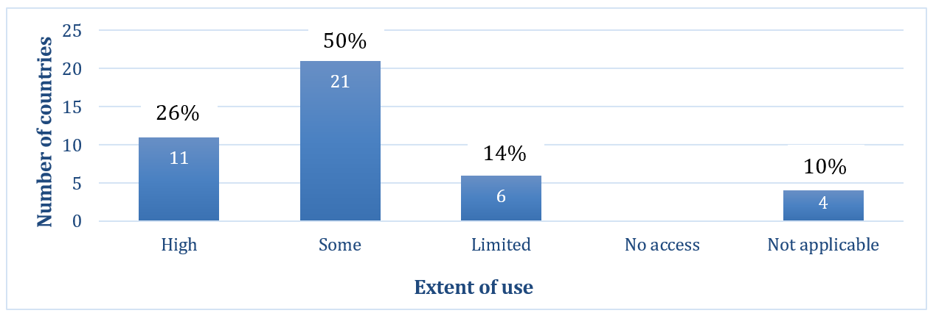
Figure 7. Extent to which research, documentation and scientific, technical and artistic studies on intangible cultural heritage are being utilized in policy-making in reporting countries (n=42) (B10.2)

Almost four fifths of reporting countries fully satisfied the core indicator B9 at the baseline in respect to the contribution of research and documentation to safeguarding. Three fifths of reporting countries fully or largely satisfied the core indicator B10 at the baseline, regarding the accessibility of research and documentation findings and their utilization to strengthen policy-making and improve safeguarding.
Most reporting countries have, for many years, made significant investments in research on the broad field encompassing intangible cultural heritage, including related topics like anthropology and folklore. Even though more research is now being done specifically on intangible cultural heritage safeguarding within the framework of the Convention, studies of the impact of safeguarding actions remain relatively rare. Some reports mentioned the need for more dedicated funding for intangible cultural heritage-related research, especially that undertaken by community actors, and a clearer articulation between research and intangible cultural heritage safeguarding.

Thematic area IV - Policies, legal and administrative measures
Establishing a set of relevant policies and/or legal and administrative measures creates an important basis for supporting the design, development, delivery and implementation of effective and sustainable programmes and activities for safeguarding intangible cultural heritage in different sectors. Article 13(a) of the Convention encourages States Parties to “adopt a general policy aimed at promoting the function of the intangible cultural heritage in society, and at integrating the safeguarding of such heritage into planning programmes” (see also OD 153(b)(i)). A primary area of such policy-making and planning is likely to be the culture sector, where action plans and strategies for intangible cultural heritage safeguarding may also be developed (see ODs 1, 2 and 171(d)) with the involvement of communities, groups and individuals concerned, in line with Article 15.
In the Convention, education is given particular attention as a means of ensuring respect for intangible cultural heritage and raising awareness of its importance (Article 1) as well as an important locus for safeguarding intangible cultural heritage through supporting its transmission (Article 2.3). Article 14(a)(ii) of the Convention also emphasizes the desirability of “specific educational and training programmes within the communities and groups concerned” as a means to “ensure recognition of, respect for, and enhancement of the intangible cultural heritage in society”. Policies in other development sectors, including inclusive social or economic development, and environmental sustainability, can be established or revised to consider intangible cultural heritage and its safeguarding in line with the Ethical Principles. The Convention’s Article 13(a) refers to the importance of “integrating the safeguarding of [intangible cultural heritage] into planning programmes”, and more detailed guidance is given in Chapter VI of the Operational Directives.
The Periodic Report thus contains a number of questions about policies, legal and administrative measures that support intangible cultural heritage safeguarding and how communities, groups and individuals concerned are involved in policy-making. These questions are as follows:

List of core indicators and assessment factors on policies, legal and administrative measures (B11-B14)
Core Indicators | Assessment According to the Following
B11. Extent to which policies as well as legal and administrative measures in the field of culture reflect the diversity of intangible cultural heritage and the importance of its safeguarding and are implemented | - Cultural policies and/or legal and administrative measures integrating intangible cultural heritage and its safeguarding, and reflecting its diversity, have been established or revised and are being implemented.
 | - National or sub-national strategies and/or action plans for intangible cultural heritage safeguarding are established or revised and are being implemented, including safeguarding plans for specific elements, whether or not inscribed.
 | - Public financial and/or technical support for the safeguarding of intangible cultural heritage elements, whether or not inscribed, is provided on an equitable basis, in relation to the overall support for culture and heritage at large, while bearing in mind the priority for those identified as in need of urgent safeguarding.
 | - Cultural policies and/or legal and administrative measures integrating intangible cultural heritage and its safeguarding are informed by the active participation of communities, groups and individuals.
B12. Extent to which policies as well as legal and administrative measures in the field of education reflect the diversity of intangible cultural heritage and the importance of its safeguarding and are implemented | - Policies and/or legal and administrative measures for education are established or revised and implemented to ensure recognition of, respect for and enhancement of intangible cultural heritage.
 | - Policies and/or legal and administrative measures for education are established or revised and implemented to strengthen transmission and practice of intangible cultural heritage.
 | - Policies and/or legal and administrative measures promote mother tongue instruction and multilingual education.
B13. Extent to which policies as well as legal and administrative measures in fields other than culture and education reflect the diversity of intangible cultural heritage and the importance of its safeguarding and are implemented | - The Ethical Principles for Safeguarding Intangible Cultural Heritage are respected in development plans, policies and programmes.
 | - Policies and/or legal and administrative measures for inclusive social development and environmental sustainability are established or revised to consider intangible cultural heritage and its safeguarding.
 | - Policies and/or legal and administrative measures to respond to situations of natural disaster or armed conflict are established or revised to include the intangible cultural heritage affected and to recognize its importance for the resilience of the affected populations.
 | - Policies and/or legal and administrative measures for inclusive economic development are established or revised to consider intangible cultural heritage and its safeguarding.
 | - Favourable financial or fiscal measures or incentives are established or revised to facilitate and/or encourage practice and transmission of intangible cultural heritage and increase availability of natural and other resources required for its practice.
B14. Extent to which policies as well as legal and administrative measures respect customary rights, practices and expressions, particularly as regards the practice and transmission of intangible cultural heritage | - Forms of legal protection, such as intellectual property rights and privacy rights, are provided to intangible cultural heritage practitioners, bearers and their communities when their intangible cultural heritage is exploited by others for commercial or other purposes.
 | - The importance of customary rights of communities and groups to land, sea and forest ecosystems necessary for the practice and transmission of intangible cultural heritage is recognized in policies and/or legal and administrative measures.
 | - Policies and/or legal and administrative measures recognize expressions, practices and representations of intangible cultural heritage that contribute to dispute prevention and peaceful conflict resolution.

Summary of analytical findings
Policies and/or legal and administrative measures in the culture sector that incorporated intangible cultural heritage and its safeguarding and reflected its diversity were reported by all but one country (B11.1). Some of these policies established the competent bodies for implementing the Convention, or gave new mandates to existing bodies, and set up inventories and associated processes to realize this aim. In Bosnia and Herzegovina, for example, several sub-national administrations amended laws on museums and cultural heritage to include intangible cultural heritage and make provision for inventorying and safeguarding it within the framework of the Convention.
Equitable public financial and/or technical support for intangible cultural heritage safeguarding, especially for inventoried elements, was reported by all countries, although only about half prioritized intangible cultural heritage in need of urgent safeguarding (B11.3). A number of reports mentioned that more funding still goes to tangible than intangible heritage. Aside from inventorying and documentation, financial and technical support included subsidizing festivals, culinary and craft fairs, workshops, educational and awareness-raising events, meeting places or venues, and safeguarding projects, as well as offering grants and prizes for bearers, cultural organizations and NGOs. In Slovakia, for example, the Ministry of Culture funded vouchers, subsidies and grants for practitioners, including marginalised groups; the public institution Minority Cultures Fund supported projects safeguarding the intangible cultural heritage of national minorities. Some countries provided support through lottery funding (Switzerland) and tax incentives for cultural initiatives and private enterprises (for example, in Belarus, Hungary and Türkiye).
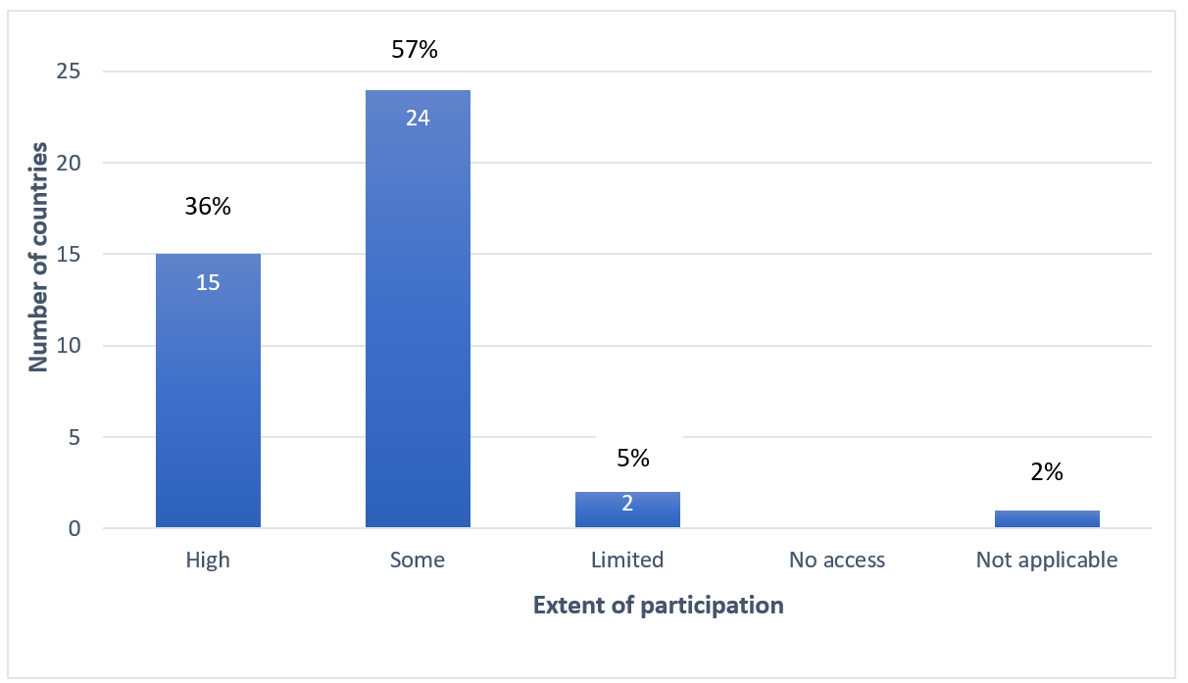
Almost all countries reported some community participation informing cultural policies and administrative measures, but only about a third reported high levels of such participation (B11.4).

Figure 8. Extent of participation of communities, groups and individuals in cultural policy-making and implementation in reporting countries (n=42) (B11.4)

Nearly four fifths of reporting countries have established policies, legal or administrative measures in the education sector that ensure recognition of, respect for and enhancement of intangible cultural heritage (B12.1), or strengthen its transmission (B12.2). While several countries (such as Greece and Luxembourg) reported increased references to intangible cultural heritage or the Convention in education policies, many education policies do not specifically mention intangible cultural heritage. Some policies focus more broadly on culture, intercultural or multicultural education (such as in Austria, Poland and Slovakia), folklore and folk culture (such as in Hungary, Lithuania and Türkiye), as well as on language and other related concepts. Multilingual and mother-tongue education policies have been discussed above in the context of cultural diversity.
Policies for inclusive social development and environmental sustainability (B13.2), or inclusive economic development (B13.4), took intangible cultural heritage into consideration in around four fifths of the countries, usually in the context of cultural tourism, festivals, traditional foodways and craft. About half of the countries took intangible cultural heritage into consideration in policies responding to situations of natural disaster or armed conflict (B13.3) or recognized intangible cultural heritage that contributes to peaceful conflict prevention and resolution (B14.3). Such policies ranged from legislation proscribing hate speech, to policies supporting festivals or remembrance days, or provisions supporting multiculturalism and inclusion in identifying intangible cultural heritage elements for safeguarding.
Almost all countries reported that forms of legal protection, such as intellectual property rights and privacy rights, were available to communities, groups and individuals when their intangible cultural heritage is exploited by others for commercial or other purposes (B14.1). For example, Czechia’s Copyright Act permits free use of products of traditional folk culture, but since 2000, has included the provision that “such works may only be used in a way that shall not detract from their value”. Several countries mentioned the importance of training programmes to increase access to legal protections. In Spain, the Intangia Association worked with experts and community members to develop good practices on managing intellectual property linked to intangible cultural heritage.
The Convention’s Ethical Principles are respected in development plans, policies and programmes relating to intangible cultural heritage in almost all of the countries (B13.1). Alignment of policies with ethical approaches in the field of intangible cultural heritage was not always specifically achieved by referencing the Ethical Principles, but by following more general legal frameworks, such as constitutional laws, sustainable development and culture policies, and regulations for environmental management or urban planning.
Almost all of the reporting countries fully satisfied the core indicator B11 at the baseline, in regard to policies in the culture sector. With regard to the integration of intangible cultural heritage in policies in the education sector, just over two thirds of countries satisfied the core indicator B12 at the baseline. About a third of all reporting countries fully satisfied the core indicator B13 at the baseline, in regard to the integration of intangible cultural heritage in policies in other sectors. Just under half of the countries fully satisfied the core indicator B14 at the baseline in regard to respect for customary rights, practices and expressions in policies.
While intangible cultural heritage was reportedly fairly well integrated into culture and education policies, and in areas like tourism, further elaboration of intangible cultural heritage-related policies may be needed, especially in the development sector. Equitable funding for tangible and intangible heritage has generally not yet been achieved. Communities may require special assistance to access legal protection and to protect their rights, especially in a commercial context. The reports highlighted the benefits of international cooperation, legal reform, community-based training and the development of guidance to maximize community benefit from the use of legal protections for intangible cultural heritage safeguarding.

Thematic area V - The role of intangible cultural heritage in society
The Convention suggests that intangible cultural heritage is of importance to communities, groups and individuals concerned, as it ‘provides them with a sense of identity and continuity, thus promoting respect for cultural diversity and human creativity’ (Article 2.1). Of course, specific elements of intangible cultural heritage have particular meaning and value to bearer communities, including as a means of dialogue, a source of knowledge and skills, and a resource for sustainable development. The requirement of ‘mutual respect among communities, groups and individuals’ figures into the Convention’s definition of intangible cultural heritage (Article 2.1), and the Convention’s aim to “ensure respect for the intangible cultural heritage of the communities, groups and individuals concerned” (Article 1(b)) implies respect for those people as well as their intangible cultural heritage.
The Convention also recommends that States Parties adopt “a general policy aimed at promoting the function of the intangible cultural heritage in society, and at integrating the safeguarding of such heritage into planning programmes” (Article 13(a)). These policies should be inclusive and non-discriminatory, in accordance with the emphasis on cultural diversity in the Convention’s Preamble, Article 2.1, Article 11 and related texts. The Operational Directive paragraph 174, for example, says that “States Parties shall endeavour to ensure that their safeguarding plans and programmes are fully inclusive of all sectors and strata of society, including indigenous peoples, migrants, immigrants and refugees, people of different ages and genders, persons with disabilities and members of vulnerable groups, in conformity with Article 11 of the Convention”.
The Periodic Report thus contains a number of questions about the role of intangible cultural heritage in society, particularly for bearer communities, and how it is being promoted and recognized, for example in development interventions. These are as follows:

List of core indicators and assessment factors on the role of intangible cultural heritage in society (B15-B16)
Core Indicators | Assessment According to the Following
B15. Extent to which the importance of intangible cultural heritage and its safeguarding in society is recognized, both by the communities, groups and individuals concerned and by society at large | - Communities, groups and individuals use their intangible cultural heritage for their well-being, including in the context of sustainable development programmes.
 | - Communities, groups and individuals use their intangible cultural heritage for dialogue promoting mutual respect, conflict resolution and peace-building.
 | - Development interventions recognize the importance of intangible cultural heritage in society as a source of identity and continuity, and as a source of knowledge and skills, and strengthen its role as a resource to enable sustainable development.
B16. Extent to which the importance of safeguarding intangible cultural heritage is recognized through inclusive plans and programmes that foster self-respect and mutual respect | - Intangible cultural heritage safeguarding plans and programmes are inclusive of all sectors and strata of society, including but not limited to:  - indigenous peoples;  - groups with different ethnic identities;  - migrants, immigrants and refugees;  - people of different ages;  - people of different genders;  - persons with disabilities;  - members of vulnerable groups.
 | - Self-respect and mutual respect are fostered among communities, groups and individuals through safeguarding plans and programmes for intangible cultural heritage in general and/or for specific elements of intangible cultural heritage, whether or not inscribed.

Summary of analytical findings
Communities, groups and individuals were reported by almost all countries in this cycle to have used their intangible cultural heritage for promoting well-being (B15.1). Practising intangible cultural heritage such as festivals, storytelling and traditional games was reported to contribute to collective memory and identity, and foster a sense of community. In Austria, efforts to safeguard Slovenian-language field and house names in the region of Carinthia led to greater local appreciation of their value, transnational dialogue and peace-building with neighbouring Slovenian areas.
Community uses of intangible cultural heritage for wellbeing were frequently intertwined with maintaining health, livelihoods and environmental sustainability, which promotes resilience. Through sale of traditional foods, crafts or cultural tourism, intangible cultural heritage practice in many cases supported livelihoods, but in a few cases community members reported that they incurred unremunerated costs from organization of events. Craft work such as miniature painting (Azerbaijan), knitting (Denmark) and practices such as “yoik” performances (a vocal tradition in Sápmi, from Norway’s report) was reported to have positive mental health effects. The communal therapeutic value of craft for the health of older people or as a rehabilitative method in correctional facilities was noted in several reports. A number of countries mentioned the importance of cooking, fishing, hunting, foraging and agricultural practices in promoting wellbeing.
As already indicated above, most countries reported that communities, groups and individuals used their intangible cultural heritage for dialogue promoting mutual respect, conflict resolution and peace-building (B15.2), and that safeguarding also promoted self-respect and mutual respect (B16.2). Some forms of intangible cultural heritage themselves promoted conflict resolution and peace-building. In Germany, for example, the “Dragon Stab” of Furth in the Forest folk theatre (Bavaria) has tackled current social developments and flagged up possible solutions taken from parallel situations in history. Where intangible cultural heritage practices caused debate about human rights or environmental issues, however, as discussed in the introductory section, various strategies had to be explored, including guidelines and dialogue. In Belgium, a day of citizen consultation was held to discuss positive and negative aspects, relating to human rights and anti-racism, of the “Savage of the Ducasse of Ath”, a character associated with the inscribed element Processional giants and dragons in Belgium and France. The discussion highlighted the need for further dialogue and information exchange between affected parties.
Raising awareness about the diversity of intangible cultural heritage itself promoted mutual respect and inclusion, and reduced conflict, as a number of countries noted, especially in regard to marginalized or minority groups. As already mentioned above, inclusivity or non-discrimination of various kinds has been mandated in policies of government agencies or other organizations in most reporting countries. Most countries also reported involving diverse groups in safeguarding plans and programmes (B16.1). Intangible cultural heritage practice was often used as a method of involving multiple age groups and people with disabilities in fun communal activities, such as sport, music or craft. Some elements of intangible cultural heritage were based on inclusionary values, an example being the anti-authoritarian open-source ethos of digital experts in the Danish branch of the transnational ”Demoscene”, a loosely connected underground culture, in which enthusiasts in computer software, hardware programming and manufacturing gather together to share their work.
Development interventions recognized the importance of intangible cultural heritage in society, whether as a source of identity and continuity, as a source of knowledge and skills and as a resource for sustainable development in over four fifths of countries, as the figure below demonstrates (B15.3).

Figure 9. Recognition of the importance of intangible cultural heritage in society, in development interventions in reporting countries (n=35) (B15.3)
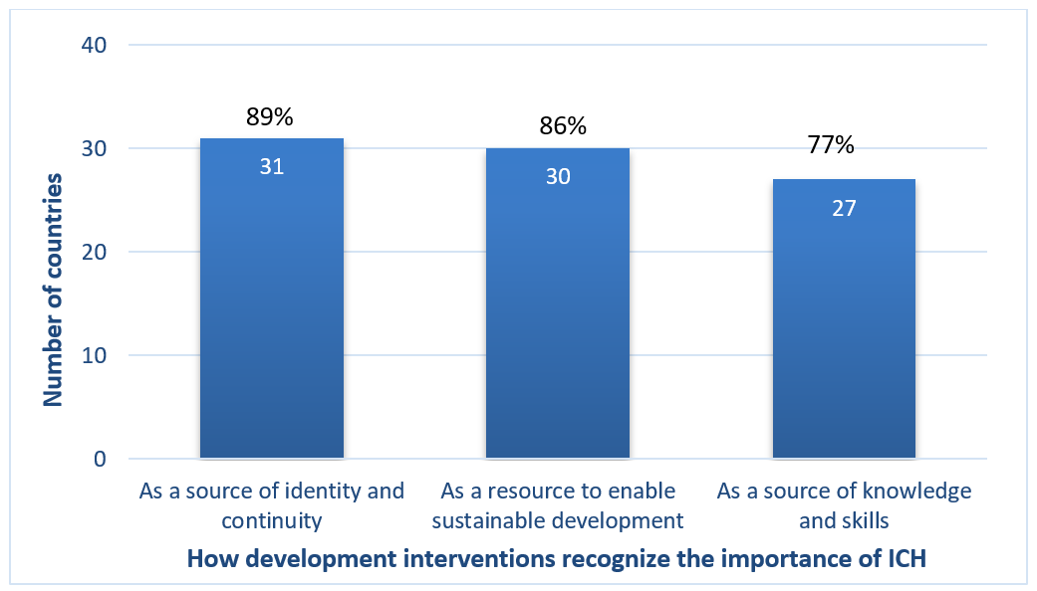

Policies and legislation, especially in the area of sustainable development, have encouraged many development programmes to be more attentive to the role of intangible cultural heritage in society. Many reports mentioned development programmes at the national level that referenced intangible cultural heritage. In Slovenia, for example, intangible cultural heritage was included in the Strategy for Sustainable Growth of Slovenian Tourism 2017-2021. The reports also indicated several ways in which intangible cultural heritage was made visible in development planning processes at the local level. In Lithuania, nearly fifty Local Action Groups, representing communities, NGOs, business and municipal administrations, developed long-term rural development strategies, including measures to safeguard cultural identity and ensure the continuity of intangible cultural heritage. The local strategies were aligned with national and EU rural development priorities and implemented with support from the European Agricultural Fund for Rural Development (LEADER) initiative of the EU.
Development initiatives frequently referenced intangible cultural heritage in relation to agriculture, land use planning and environmental management, such as drystone walling. Development strategies recognizing the importance of intangible cultural heritage for identity and livelihoods included educational activities promoting cultural values and handicrafts in the context of tourism and eco-businesses, as well as encouraging local youth to learn traditional music. A number of reports noted the importance of intangible cultural heritage in representing the identities of specific towns and areas within a country, for example through festivals, food traditions, language or place names. In Malta, small family-run businesses making traditional foods and crafts benefited from access to government subsidized premises such as the “Ta’ Qali Craft Village and Interpretation Centre”.
About three fifths of the reporting countries fully satisfied this core indicator B15 at the baseline. Nearly four fifths of reporting countries fully satisfied the core indicator B16 at the baseline, regarding the inclusivity of safeguarding plans and programmes that foster self-respect and mutual respect.
Intangible cultural heritage is well recognized in many countries as a contributor to well-being, peace and conflict reduction, and to environmental and economic development, particularly through festivals and tourism, and the traditional food, agriculture and handicrafts sectors. Further work may need to be done on integrating safeguarding into national development strategies, synergizing these with local planning processes, and assessing the impact of development initiatives on intangible cultural heritage safeguarding. Collaborative dialogue across States Parties may help identify effective ways of preventing, regulating and responding to situations where intangible cultural heritage practice is a subject of conflict and disagreement.

Thematic area VI – Awareness raising about the importance of intangible cultural heritage
Awareness raising about the importance of intangible cultural heritage is one of the Convention’s main four purposes (Article 1(c)) and can help ensure broad appreciation of it. To this end, States are encouraged to “ensure recognition of, respect for, and enhancement of the intangible cultural heritage in society, in particular through: (i) educational, awareness-raising and information programmes, aimed at the general public, in particular young people” (Article 14(a), see also ODs 100-117). Awareness-raising activities should be carried out with wide community participation in line with Article 15, and in conformity with relevant Ethical Principles.
The Periodic Report thus contains a number of questions about awareness-raising activities, community and youth participation in them, the role of media and public sector actors, and alignment with the Ethical Principles. These are as follows:

List of core indicators and assessment factors on awareness raising about the importance of intangible cultural heritage (B17-B20)
Core Indicators | Assessment According to the Following
B17. Extent to which communities, groups and individuals participate widely in raising awareness about the importance of intangible cultural heritage and its safeguarding | - Awareness-raising actions reflect the inclusive and widest possible participation of communities, groups and individuals concerned.
 | - The free, prior, sustained and informed consent of communities, groups and individuals concerned is secured for conducting awareness-raising activities concerning specific elements of their intangible cultural heritage.
 | - The rights of communities, groups and individuals and their moral and material interests are duly protected when raising awareness about their intangible cultural heritage.
 | - Youth are actively engaged in awareness-raising activities, including collecting and disseminating information about the intangible cultural heritage of their communities or groups.
 | - Communities, groups and individuals use information and communication technologies and all forms of media, in particular new media, for raising awareness of the importance of intangible cultural heritage and its safeguarding.
B18. Extent to which media are involved in raising awareness about the importance of intangible cultural heritage and its safeguarding and in promoting understanding and mutual respect | - Media coverage raises awareness of the importance of intangible cultural heritage and its safeguarding and promotes mutual respect among communities, groups and individuals.
 | - Specific cooperation activities or programmes concerning intangible cultural heritage are established and implemented between various intangible cultural heritage stakeholders and media organizations, including capacity-building activities.
 | - Media programming on intangible cultural heritage is inclusive, utilizes the languages of the communities and groups concerned, and/or addresses different target groups.
 | - Media coverage of intangible cultural heritage and its safeguarding is in line with the concepts and terminology of the Convention.
B19. Extent to which public information measures raise awareness about the importance of intangible cultural heritage and its safeguarding and promote understanding and mutual respect | - Practitioners and bearers of intangible cultural heritage are acknowledged publicly, on an inclusive basis, through policies and programmes.
 | - Public events concerning intangible cultural heritage, its importance and safeguarding, and the Convention, are organized for communities, groups and individuals, the general public, researchers, the media and other stakeholders.
 | - Programmes for promotion and dissemination of good safeguarding practices are fostered and supported.
 | - Public information on intangible cultural heritage promotes mutual respect and appreciation within and between communities and groups.
B20. Extent to which programmes raising awareness of intangible cultural heritage respect the relevant ethical principles | - The Ethical Principles for Safeguarding Intangible Cultural Heritage are respected in awareness-raising activities.
 | - Ethical principles, particularly as embodied in relevant professional codes or standards, are respected in awareness-raising activities.

Summary of analytical findings
Community participation in awareness raising about their intangible cultural heritage (B17.1), with their free, prior, sustained and informed consent (B17.2), was reported by almost all countries. Inventorying processes, in particular, seem to have helped to create both a focus for community engagement and dialogue, and an opportunity for more general information sharing. In most reporting countries, public information policies and programmes publicly acknowledged intangible cultural heritage practitioners on an inclusive basis (B19.1), for example as beneficiaries of prizes, awards, grants and titles.
Mechanisms to facilitate youth engagement in awareness raising about intangible cultural heritage were reported by almost all countries (B17.4), encouraged by the use of digital platforms and the inclusion of intangible cultural heritage in education. Strategies for engaging young people included the creation of youth committees or youth councils for safeguarding (for example in Armenia, Cyprus, Italy and the Netherlands), summer schools (for example in Georgia, Romania and Slovenia), internships and volunteering programmes (for example in Belgium and Poland) or social media capacity building (reported by many countries). In Azerbaijan, games, traditional meals and music and dance performances were held on city streets during Novruz, to draw the attention of young people to traditional culture.
Community use of digital and new media for raising awareness of the importance of intangible cultural heritage and its safeguarding was reported by all countries (B17.5). Awareness-raising mechanisms included virtual exhibitions, online masterclasses, video conferences and live online broadcasting of events and performances. Digital platforms were used to engage communities in recovering vocabulary associated with intangible cultural heritage practices, groups or places, and in sharing knowledge and information, especially during the COVID-19 pandemic, as mentioned above. In Georgia, for example, an online bread-making masterclass was introduced and social media was used to discuss a nomination to the Convention’s international Lists. In Italy, the community of violinmakers in Cremona used online media for distance learning and to broadcast music performances on YouTube; this was shared among other pandemic responses on the Convention’s website.
Most countries reported their media coverage to be inclusive, also regarding language and dialect (B18.3), and that awareness-raising activities generally conformed with the Convention’s Ethical Principles (B20.1). Both media coverage and public information on intangible cultural heritage were reported to have promoted mutual respect in most countries (B18.1, B19.4). In Czechia, the television show “Sousedé” (the Neighbours), for example, aimed to foster mutual understanding and respect in society by providing insights into the changing lifestyles and customs of diverse social groups, including national minorities, and thereby reflecting on issues of social integration and co-existence.
Most countries reported that cooperation activities or programmes concerning intangible cultural heritage, including capacity-building activities, were jointly established and implemented between the media and other intangible cultural heritage stakeholders (B18.2). In the Caribbean region of the Netherlands, the Bonairean Historical Cultural Foundation (FuHiKuBo), accredited as an NGO under the Convention in 2020, has raised awareness about intangible cultural heritage on all six island territories within the Kingdom. The NGO has created and published interviews with bearers and practitioners online, made them freely available through radio and TV programmes, published them in booklets and newspaper articles, and made them accessible for future use in its archive.
In many countries, public broadcasting services worked with government agencies, NGOs, heritage institutions and communities to promote intangible cultural heritage as well as to publicize safeguarding and inventorying projects. However, some reports noted that intangible cultural heritage practitioners identified significant resource and cost constraints associated with participation in such cooperation activities, since they were often expected to work for free.
A number of countries raised concerns about media coverage of intangible cultural heritage and its safeguarding not being in line with the concepts and terminology of the Convention (18.4). There was persistent confusion between the 1972 and 2003 Conventions, for example, and many media reports focused on claims for the “authenticity” and “uniqueness” of intangible cultural heritage elements. Ongoing communication with journalists, briefings, press releases, publications and glossaries have helped to some extent in educating the media on the terminology and the concepts of the Convention.
Intangible cultural heritage-related media coverage was reported to raise awareness of the importance of intangible cultural heritage and its safeguarding in all countries (B18.1). This was especially in the context of inclusion of elements on inventories, or inscription on the international Lists of the Convention or selection for the Register of Good Safeguarding Practices. In Finland, to assist media engagement by communities after inscription of their element on the National Inventory, they were provided with a communication package. This package included the Living Heritage logo developed at the national level, information for press releases, guidance for creating communications plans and good examples of media campaigns.

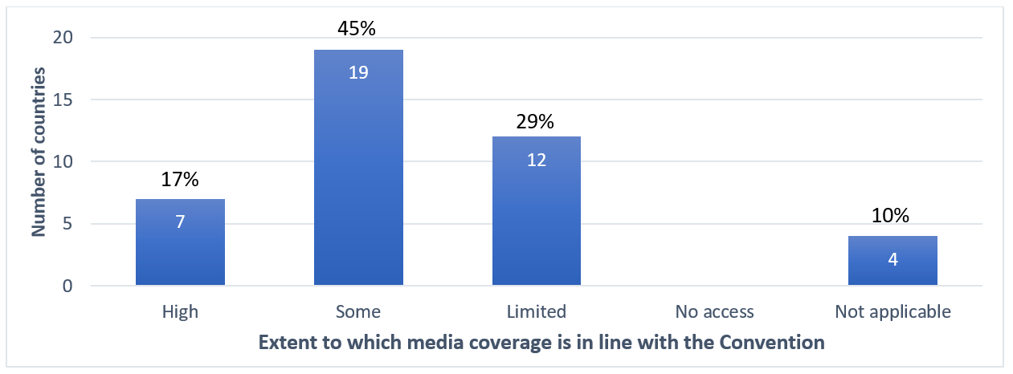
Figure 10. Extent of media coverage in reporting countries about intangible cultural heritage and its safeguarding, in line with the concepts and terminology of the Convention (n=42) (B18.4)

Nearly four fifths of reporting countries fully satisfied the core indicator B17 and 20 at the baseline regarding community participation in awareness raising and the extent to which programmes raising awareness of intangible cultural heritage respect the relevant ethical principles. Just over four fifths fully satisfied the core indicator B19 at the baseline in regard to the extent to which public information measures raise awareness about intangible cultural heritage. Only about three fifths of reporting countries fully satisfied the core indicator B18 at the baseline, regarding the extent of media involvement in raising awareness about the importance of intangible cultural heritage and its safeguarding, and in promoting understanding and mutual respect.
Many innovative awareness-raising activities were conducted in reporting countries. As most such projects seem to have been funded by the state as part of public broadcasting initiatives or institutional mandates, more support might be needed for community-led awareness-raising projects. Funding and strategic planning may be needed to promote more effective cooperation between intangible cultural heritage stakeholders and media organisations, and to develop capacity on the concepts and terminology of the Convention.

Thematic area VII - Safeguarding activities for intangible cultural heritage
Effectively involving a broad range of actors is essential to achieving the best safeguarding results, whether for intangible cultural heritage in general or for specific elements of intangible cultural heritage. Key among these actors are the communities, groups and, where appropriate, individuals concerned, whose widest possible participation in the safeguarding and management of their intangible cultural heritage is encouraged in Article 15, the Operational Directives and Ethical Principles. This does not simply imply a two-way partnership between the State and such communities; rather, the Operational Directives have also developed an important role in safeguarding for NGOs and other civil society actors (e.g. ODs 90, 108, 157(e), 158(b), 162(e), 163(b)), as well as the private sector (OD 187). The effectiveness of intangible cultural heritage safeguarding programmes and measures can be increased and improved through regular monitoring and through scientific, technical and artistic studies to provide feedback about positive or negative impacts. Such monitoring studies can be done by communities concerned, NGOs and other civil society bodies, research institutions and centres of expertise, scholars and experts.
The Periodic Report thus contains a number of questions about engagement of diverse actors in safeguarding activities. These are as follows:

List of core indicators and assessment factors on safeguarding activities for intangible cultural heritage (B21-B22)
Core Indicators | Assessment According to the Following
B21. Extent to which engagement for safeguarding intangible cultural heritage is enhanced among stakeholders | - Communities, groups and individuals participate, on an inclusive basis and to the widest possible extent, in the safeguarding of intangible cultural heritage in general and of specific elements of intangible cultural heritage, whether or not inscribed.
 | - NGOs and other civil society actors participate in the safeguarding of intangible cultural heritage in general, and of specific elements of intangible cultural heritage, whether or not inscribed.
 | - Private sector entities participate in the safeguarding of intangible cultural heritage, and of specific elements of intangible cultural heritage, whether or not inscribed, respecting the Ethical Principles for Safeguarding intangible cultural heritage.
B22. Extent to which civil society contributes to monitoring of intangible cultural heritage safeguarding | - An enabling environment exists for communities, groups and individuals concerned to monitor and undertake scientific, technical and artistic studies on intangible cultural heritage safeguarding programmes and measures.
 | - An enabling environment exists for NGOs, and other civil society bodies to monitor and undertake scientific, technical and artistic studies on intangible cultural heritage safeguarding programmes and measures.
 | - An enabling environment exists for scholars, experts, research institutions and centres of expertise to monitor and undertake scientific, technical and artistic studies on intangible cultural heritage safeguarding programmes and measures.

Summary of analytical findings
High levels of inclusive community participation in intangible cultural heritage safeguarding were reported in about three quarters of the countries (B21.1). For example, the Safeguarding Plan on Esparto Culture was elaborated after extensive participatory research with bearers and practitioners in various regions of Spain. Community participation was particularly noted in the process of inventorying, especially identifying risk factors to intangible cultural heritage elements, and in the elaboration of safeguarding measures. This helped in resolving conflicts and promoting broader outcomes from safeguarding, such as well-being and livelihoods. Armenia reported that in the last few years the scope of community participation in intangible cultural heritage activities organized by the Ministry of Education, Science, Culture and Sports has increased, as more NGOs and intangible cultural heritage bearers, including women, displaced people and members of vulnerable groups, have competed for cultural programme funding.
Two thirds of the countries reported high levels of participation in intangible cultural heritage safeguarding by NGOs and other civil society organizations (B21.2), many of which were volunteer organizations comprised of intangible cultural heritage bearers. Many reports noted the capacity of NGOs to connect different stakeholders and involve minority groups, often providing funding to this end. In Azerbaijan, the Ministry of Culture regularly held consultations on the role of NGOs in the sustainable development of culture to promote cooperation on safeguarding.

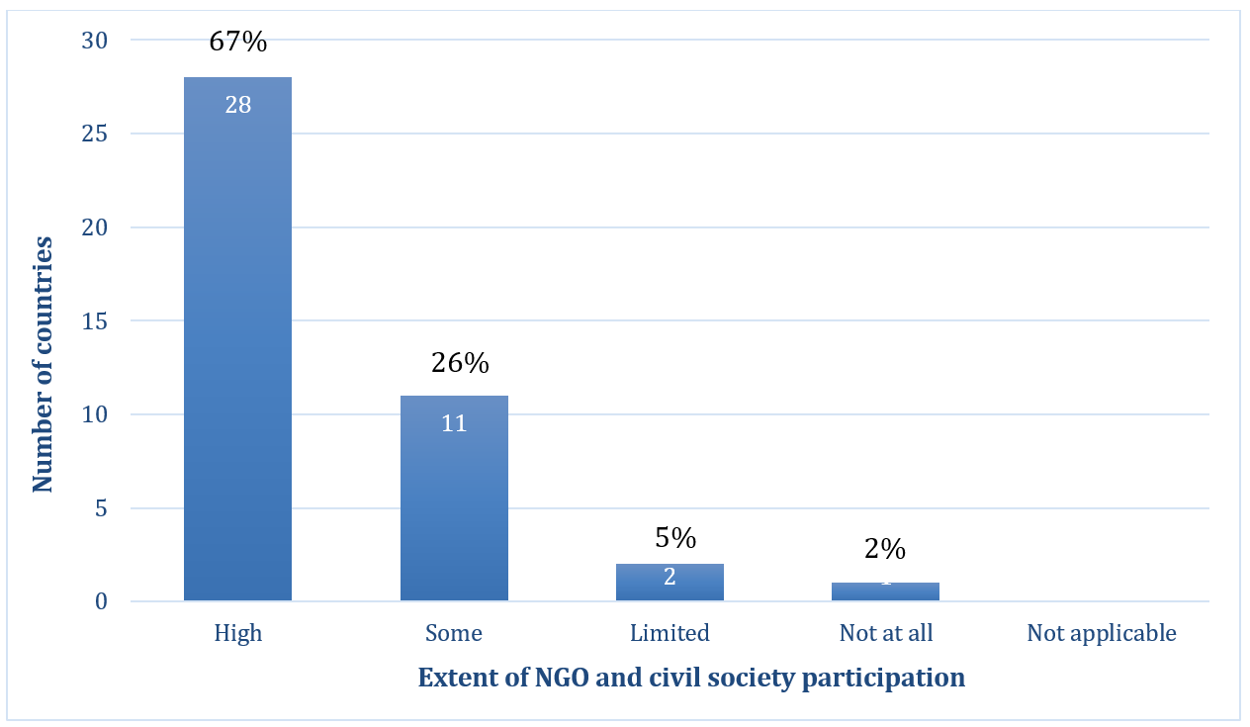
Figure 11. Extent of participation by NGO and other civil society actors in intangible cultural heritage safeguarding activities in reporting countries (n=42) (B21.2)

High levels of private sector participation in safeguarding activities were reported by only about a fifth of the countries (B21.3). Private sector contributions from banks, foundations, private museums, trade associations and businesses included provision of funding, access to materials or spaces, promotion of tourism, festivals or artisanal events, technical assistance and direct participation in safeguarding activities. In the Faroe Islands (Denmark), events such as “Seamen’s Day” and the Knitting Festival were supported financially by private companies. Navia, a wool and knitwear company in the islands, utilized wool from local farmers for their products and published a booklet with patterns for knitwear designs created by locals. In Portugal, privately-owned restaurants provided venues and income opportunities ensuring the viability of Fado performances, while also sustaining their businesses. The Georgian Wheat Producers Association researched intangible cultural heritage associated with growing local wheat varieties and led the elaboration of the plan for the protection of Georgian wheat culture.
An enabling environment for communities, groups and individuals, as well as NGOs, to undertake scientific, technical and artistic studies on intangible cultural heritage safeguarding was reported by almost all countries (B22.1, B22.2). All countries reported having an enabling environment for scholars, experts and research institutions to undertake such work (B22.3). Some reports emphasized that communities carry out studies on their own initiative. In Poland, for example, community members carried out a project to document and disseminate knowledge about the celebration of St. Barbara's Day (“Barbórka”), which was inscribed on the national inventory in 2018. Their research supported the implementation of the safeguarding plan, enhancing transmission and popularization of the element. In Greece, winemakers and viticulturalists in Santorini were involved, alongside academics and local authorities, in a 2015 conference sharing research for safeguarding local growing, pruning and winemaking traditions inscribed on the national inventory. However, challenges were also reported in encouraging community participation in research and optimal use of research results.
Over four fifths of reporting countries fully or largely satisfied the core indicator B21 at the baseline, regarding engagement of stakeholders for safeguarding intangible cultural heritage. Nearly all fully satisfied the core indicator B22 at the baseline, regarding engagement for safeguarding intangible cultural heritage being enhanced among stakeholders.
Reporting countries have provided extensive institutional support to researchers and NGOs undertaking safeguarding actions. While community engagement in safeguarding was reportedly high, some challenges remain in funding community-led safeguarding work, and stimulating effective use of research by communities. Practitioners from minority or marginalized groups may benefit from further safeguarding actions linked to sustaining livelihoods, as long as sufficient attention is paid to avoiding risks of over-commercialization. A systematic survey of the involvement of the private sector in intangible cultural heritage safeguarding, which seems rather low, could be helpful in identifying new opportunities for public-private cooperation and highlighting good practices.

Thematic area VIII - International cooperation and engagement
One of the Convention’s four purposes is “to provide for international cooperation and assistance” (Article 1(d)), and the Convention further defines international cooperation as including joint initiatives, among other things (Article 19). International mechanisms such as International Assistance, inscription on the Lists and Register of the Convention (especially mechanisms allowing multinational nominations), enable collaboration, cooperation and communication between States Parties at the international level. Article 19 encourages States “to cooperate at the bilateral, sub-regional, regional and international levels,” and such cooperation can be formalized through networking and institutional cooperation, including accreditation of NGOs.
The Periodic Report thus contains a number of questions about international cooperation and engagement in safeguarding activities at the bilateral, sub-regional, regional and international levels. These are as follows:

List of core indicators and assessment factors on international cooperation and engagement (B24-B25)
Core Indicators | Assessment According to the Following
B24. Percentage of States Parties actively engaged with other States Parties in cooperation for safeguarding | - Bilateral, multilateral, regional or international cooperation is undertaken to implement safeguarding measures for intangible cultural heritage in general
 | - Bilateral, multilateral, regional or international cooperation is undertaken to implement safeguarding measures for specific elements of intangible cultural heritage, in particular those in danger, those present in the territories of more than one State, and cross-border elements.
 | - Information and experience about intangible cultural heritage and its safeguarding, including good safeguarding practices, is exchanged with other States Parties.
 | - Documentation concerning an element of intangible cultural heritage present on the territory of another State Party is shared with it.
B25. Percentage of States Parties actively engaged in international networking and institutional cooperation | - State Party engages, as host or beneficiary, in the activities of category 2 centres for intangible cultural heritage.
 | - International networking is fostered among communities, groups and individuals, NGOs, experts, centres of expertise and research institutes, active in the field of intangible cultural heritage.
 | - State Party participates in the intangible cultural heritage-related activities of international and regional bodies other than UNESCO.

Section A also contains some questions on accreditation of NGOs (A4), inscriptions on the Lists and programmes selected for the Register (A5), International assistance funding (A5) and synergies with other international frameworks (A7). These relate partly to core indicators B23 and B26 that will be reported only at the global level; nevertheless, some information will be included here for completeness.

Summary of analytical findings
As already mentioned above, most countries reported high levels of international cooperation on intangible cultural heritage safeguarding in general (B24.1), most frequently at the regional level and in the context of regional multilateral frameworks.
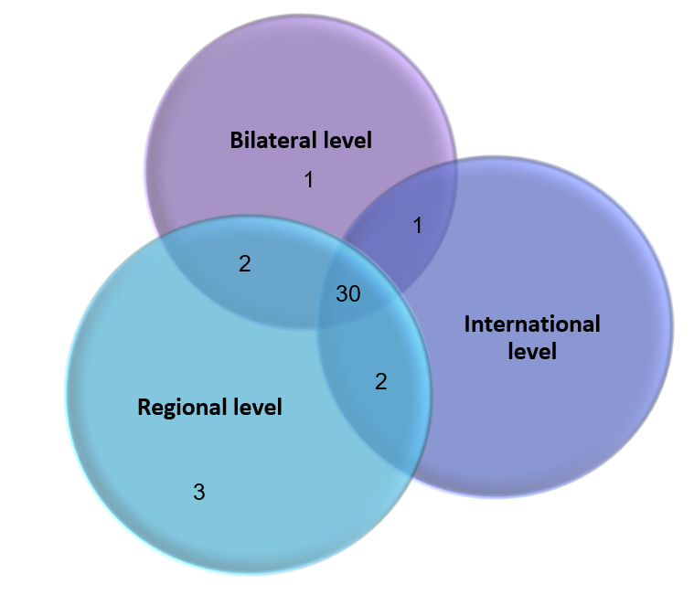
Many of these cooperations involved funded research or safeguarding projects, some examples of which have been mentioned above. Others were events, sometimes organized in cultural capitals or to commemorate certain anniversaries. For example, under the Commonwealth of Independent States (CIS) programme of events in 2021, two NGOs in Armenia organized an "Exhibition-Fair of Armenian Folk Crafts" in the city of Gyumri of Shirak marz. As an event under the Council of Europe European Heritage Days, in 2018 the Republic of Moldova hosted an exhibition called “Woven Poems” at its embassy in Talinn, Estonia, raising awareness about traditional costumes and carpets.

Figure 12. Number of countries reporting regional (n=37), bilateral (n=34) and international cooperation (n=33) on intangible cultural heritage safeguarding in general (B24.1)

Various forms of bilateral cooperation were also reported. Iceland and Norway, for example, organized a Summer Academy in 2021 called “Fiber Fokus: wool as a shared cultural heritage and art”, at which wool artists and craftspeople from the two countries exchanged knowledge and skills. A city twinning programme formed the basis of cooperation between Monaco and Sainte Dévote in Corsica (France), as both celebrate festivals commemorating the same patron saint.
A number of projects facilitated collaboration between UNESCO regions. Czechia, Poland, Serbia and Slovakia, for example, worked with China from 2016 to 2019 on an international research and academic exchange on intangible cultural heritage safeguarding. Other academic collaborations have been mentioned elsewhere in this report.
Activities that contributed to intangible cultural heritage safeguarding under UNESCO frameworks other than the Convention were shared in the reports (A7). These activities particularly related to the 1972 Convention Concerning the Protection of the World Cultural and Natural Heritage and the 2005 Convention on the Protection and Promotion of the Diversity of Cultural Expressions. For example, in Estonia, an annual Master Craftsman Contest was held in Viljandi, a UNESCO Creative City of Crafts and Folk Art. The theme of the contest for the year 2021 was ‘repairing’. This contest furthered the aims of both the 2003 and 2005 Conventions, raising awareness about intangible cultural heritage bearers and giving them recognition, as well as promoting cultural industries.
Most countries also reported synergies with international frameworks other than UNESCO, particularly the Convention on Biological Diversity (CBD) and the Ramsar Convention on Wetlands of International Importance (B25.3, A7). Several countries participated in the World Intellectual Property Organization (WIPO) Intergovernmental Committee on Intellectual Property and Genetic Resources, Traditional Knowledge and Folklore (IGC). In the Nordic countries, efforts have been made towards increased co-operation on the protection of intellectual property and other rights associated with intangible cultural heritage, such as traditional handicrafts and dress of indigenous Nordic peoples.
Two fifths of the countries fully satisfied the core indicator B24 at the baseline, regarding active engagement with other States Parties in cooperation for safeguarding. A similar proportion fully satisfied the core indicator B25 at the baseline, regarding active engagement in international networking and institutional cooperation. These scores at the baseline do not reflect the high level of international cooperation and engagement that was reported.
Countries shared many examples of cooperation at the bilateral or multilateral level, often implemented by government agencies, NGOs or academic institutions. While support for such initiatives was strong, it is not always easy to assess their impact on the safeguarding of intangible cultural heritage, or on cooperation between communities practising shared heritage. Community organizations and practitioners could benefit from increased visibility and support when undertaking cross-border cooperation in intangible cultural heritage safeguarding.
Status of elements on the Representative List
Article 16 of the Convention states that the aims of inscriptions on the Representative List are “to ensure better visibility of the intangible cultural heritage and awareness of its significance, and to encourage dialogue which respects cultural diversity”. According to Article 29 of the Convention and ODs 151-152, States Parties shall submit reports to the Committee on currently inscribed elements, including those inscribed on the Representative List. Reporting on the status of elements inscribed on the Representative List can help to raise awareness about the significance of intangible cultural heritage. It can assist in the monitoring and evaluation of the role of the List, the impact of inscription, and contribute to the safeguarding of inscribed elements. The Periodic Report thus contains a number of questions about elements inscribed on the Representative List.

Overview
Before the inscriptions at 16.COM (2021), a total of 177 elements were inscribed on the Representative List by 36 out of the 42 countries reporting in this cycle. Twenty eight of these elements were multinational nominations. The most inscriptions (19 each) were nominated by France and Türkiye. Only three of the reporting countries did not yet have inscriptions on any of the Lists or the Register by the end of the reporting cycle.
The graph below shows how many reporting countries had elements inscribed on the Representative List within a few years after ratification of the Convention. Inscriptions in 2008, some of which happened before ratification, were linked to the incorporation of ‘Masterpieces of the Oral and Intangible Heritage of Humanity’ (2001-2005) into the Representative List.

Figure 13. The time elapsed between ratification of the Convention and inscription of the first element on the Representative List of the Intangible Cultural Heritage (A5)
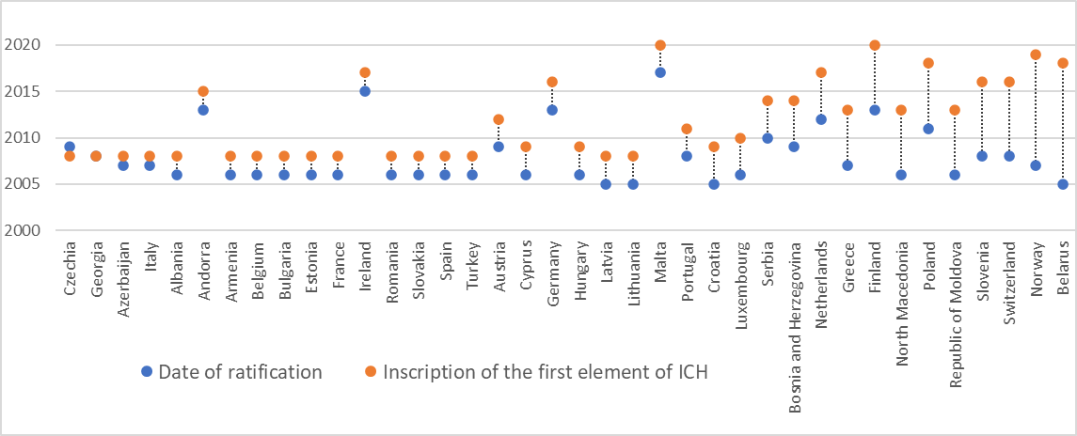

Social and cultural functions
Safeguarding of intangible cultural heritage depends on understanding and maintaining the social and cultural functions and meanings of the element for the communities, groups and individuals concerned. Section C1 of the Periodic Reporting form specifically requests information on changes to the information provided under inscription criterion R.1.
Most of the social functions of the elements analyzed for this report were reported as stable. This helps to ensure social cohesion, as for example in Bulgaria, where some of the money collected by the Survakar masquerade groups during the Surova folk feast in Pernik region (inscribed in 2015) was donated to people in need or used to complete local projects. Of course, the reports also noted changes in intangible cultural heritage practices themselves, for example when the Survakar groups mentioned above created new village celebrations. In Greece, Rebetiko lyrics continue to reflect working class experiences and the lives of marginalized groups, whether referencing the financial downturn or more recently the immigration crisis. Some reports mentioned the incorporation of current themes around social equity in the social function of inscribed elements. This included gender-inclusive adjustments in intangible cultural heritage practice, for example in Cyprus, where talented women have begun to occupy the previously exclusively male role of poetic duellist (Tsiattista), performing improvised rhyming couplets in iambic fifteen-syllable verse in family gatherings or at local folk festivals.
The social and cultural functions of some inscribed elements have been highlighted by the COVID-19 pandemic and climate change. In the Netherlands, the Craft of the miller operating windmills and watermills became more significant because many more people wanted to bake at home using traditionally milled flour during the pandemic. At the same time, climate change has elevated the importance of historical mills as auxiliary pumping stations to manage water levels. The sustainable production methods now used by the millers also generate public interest. For similar reasons, dry stone walling has attracted increased public interest in recent years as a way to promote a more sustainable environment.

Assessment of viability and current risks
The development of intangible cultural heritage safeguarding strategies is based on an assessment of the current level of viability of the element, and threats or risks to this viability, if any. This may change over time, so Section C2 of the Periodic Reporting form specifically requests information on the current viability of inscribed elements, even those on the Representative List.
Most countries reported ongoing viability of inscribed elements. Major threats mentioned in the reports included urbanization (specifically, young people moving away from rural areas), loss of interest in practice of the elements by young people, over-commercialization, counterfeit products competing with handicrafts, environmental sustainability, economic constraints and the COVID-19 pandemic. Czechia reported for example that Slovácko Verbuňk recruit dancing (2008) had become more popular across the country since inscription, but increased urbanization had led to the loss of some ceremonial contexts for its performance and also to the mixing of “verbunk” styles, with the loss of some regional repertoires. The high cost of costumes, music, refreshments and spaces for performance in urban areas hampered practice of the element, as did the economic impact of the pandemic. In Hungary, safeguarding actions after inscription and rising demand for blue print products helped to support three family-owned workshops for Blaudruck/Modrotisk/Kékfestés/Modrotlač, resist block printing and indigo dyeing, but counterfeit products remained a challenge.
As already mentioned above, the COVID-19 pandemic affected the practice and transmission of intangible cultural heritage, especially where it involved large groups of people. Many gatherings, festivals and productions associated with inscribed elements were cancelled or curtailed, and some activities moved online. Enthusiasm for intangible cultural heritage events was rekindled to some extent as normal life resumed, for example during the performance of the Saint Hubert Trumpeters of Luxembourg in June 2021.

Contribution to the goals of the List
The goals of the Representative List include ensuring visibility of the intangible cultural heritage in general, raising awareness at the local, national and international levels of its importance, as well as promoting respect for cultural diversity and human creativity, and mutual respect among communities, groups and individuals. Section C3 of the Periodic Reporting form thus requests information on how inscription of the element has contributed to achieving these goals. Answering this question requires consideration of the impact of inscription from the perspective of the goals of the Convention, and not just specific safeguarding goals relating to an inscribed element, which was challenging in some cases.
The reports noted a growing awareness about the value of intangible cultural heritage in society, aided by inscriptions on the Representative List. This seems especially true for the first inscriptions in each country, such as “Zmijanje embroidery” from Bosnia and Herzegovina (2014). In the Republic of Moldova, inscription of “Men’s group Colindat, Christmas-time ritual”, a multinational file with Romania (inscribed in 2013), has led to increased support for intangible cultural heritage practice from municipalities, museums, NGOs and communities locally. Moldovans living in other countries have used the carolling tradition to help create a stronger link with their home country, and to speak about their own cultural identity in the diaspora context. However, not all inscriptions encouraged local and national authorities, and other stakeholders, to invest more in supporting intangible cultural heritage safeguarding or to recognize its value.
Inscription on the Representative List generally promoted respect for cultural diversity and human creativity, and mutual respect among communities, groups and individuals in various ways. For example, inscription of “Shrimp fishing on horseback in Oostduinkerke” (in 2013, nominated by Belgium) has inspired the creation of numerous film reports and documentaries, both local and foreign. It has also promoted cross-border dialogue with the community of Haenyeo divers on Jeju Island (Republic of Korea) and a community of dip net fishing practitioners from the Torne river in Sweden and Finland. This has promoted understanding of and respect for diverse local artisanal fishing cultures and how to safeguard them.

Efforts to promote or reinforce the element
Safeguarding intangible cultural heritage often involves the development and implementation of safeguarding measures. Section C4 of the Periodic Reporting form thus requests information on the measures that have been implemented to promote and reinforce the element, particularly detailing any measures that might have been necessary as a consequence of its inscription.
A wide variety of safeguarding measures were implemented for inscribed elements, including provision of funding, infrastructure and legal protection, establishment of organizations with safeguarding mandates, educational and awareness-raising programmes, and support for festivals, competitions and research. For example, the Albanian Ministry of Culture supported several festivals promoting the element “Albanian folk iso-polyphony”, including the National Typological Folklore Festival of Iso-Polyphony, celebrated in Gjirokastër in November 2021. The Institute of Cultural Anthropology and Art Studies undertook research and digitization, and produced publications on Albanian iso-polyphony. Many reports mentioned awareness-raising activities. In Cyprus, the UNESCO Chair on Cultural Diversity and Intercultural Dialogue for a Culture of Peace, in close collaboration with the Cyprus National Commission for UNESCO, worked with students to create videos about intangible cultural heritage elements inscribed on the National Inventory that were used for promotion and education (e.g. Pipilla lace in Omodos and Koilani and Lefkaritiko Embroidery Lace Modi and Modulations). Several reports noted the development of specific organizations, networks or committees to implement safeguarding measures for inscribed elements. In Italy, for example, the "Italian Network of Organisations for the Protection, Promotion, and Enhancement of the Opera dei Pupi" was established to support safeguarding of the element.
As mentioned above, digital tools have become very important in implementing safeguarding measures, not only promoting awareness and public participation, but also encouraging sharing of information. In Andorra, public participation in practising and researching “Summer solstice fire festivals in the Pyrenees” was promoted through a festival website, international symposiums and a virtual museum. A Mediterranean Fire Festivals Symposium was held in Andorra la Vella in 2019, linking the element to related regional manifestations. The Lithuanian National Commission for UNESCO in partnership with the Lithuanian Culture Research Institute created a website for the element “Cross-crafting and its symbolism”, containing the maps of cross-crafting sites and cross crafters. This was part of other safeguarding actions. Under the Council of Europe Cultural Routes programme, the “Santiago de Compostela Pilgrim Routes” included the Hill of Crosses, which promoted the craft and helped to sustain cross-crafters’ livelihoods. A Programme of Scholarships for Art Creators and a cross-crafters’ certification administered by the Lithuanian Ministry of Agriculture supported practitioner training.
Inscription on the Representative List necessitated implementation of additional safeguarding measures in some cases, to address negative effects of greater visibility. To protect the livelihoods of practitioners of Azerbaijani carpet weaving against unfair competition from mass-produced products, the Museum of Azerbaijani Carpets has reinforced its procedures and requirements for the certification of carpets, especially those sold to tourists. Certification was based on criteria including the quality of wool, use of natural dyes, traditional weaving technologies and patterns.

Community participation in safeguarding
The participation of communities, groups and individuals is essential in safeguarding intangible cultural heritage, assisted where relevant by NGOs. Section C5 of the Periodic Reporting form thus requests information on such participation and prospects for its continuation in the future.
Community participation was generally directed towards supporting continued practice and transmission of the element. Romania’s report noted that performers, teachers, the local administration, parish priests and families in the area were very active in safeguarding the element “Men’s group Colindat, Christmas-time ritual”, organizing events, a children’s folk ensemble and ensembles for non-professional dancers. In Croatia, children from various villages worked with elders to perform their own versions of the element “Sinjska Alka Knights’ Tournament”, broadcast on local media. Community involvement in the practice of inscribed elements was very inclusive in some cases. The practice of traditional music and dance in Setesdal (Norway) involved a wide range of practitioners and audience members living in or visiting the valley, including migrant workers and refugees. In North Macedonia, the “Feast of the Holy Forty Martyrs in Štip” involved all city inhabitants of different ages and genders, social, economic and religious backgrounds, including Orthodox Christians and Muslims, the latter predominantly Roma.
Community members sometimes established organizations of their own, and frequently worked with other stakeholders, including museums and NGOs, to develop and implement safeguarding measures. For example, in Türkiye, nearly 500 archery clubs representing practitioners of “Traditional Turkish Archery” enrolled as members of the Traditional Turkish Archery Federation, established in 2019. The Federation worked with community members and other NGOs to draw up a safeguarding plan for the element, implement it and to monitor safeguarding efforts after inscription.

Institutional context
Community organizations and other stakeholder agencies generally play an essential role in the safeguarding of inscribed intangible cultural heritage elements, and carry formal responsibilities for doing so in some contexts. Section C6 of the Periodic Reporting form thus requests information on the institutional context for the element inscribed on the Representative List, including competent bodies involved in its management and/or safeguarding, and organizations of the community or group concerned with the element and its safeguarding.
Community organizations were generally involved in safeguarding inscribed elements. In Germany, for example, associations such as the German Federation of Organ Experts (VOD) and the Federation of German Master Organ Builders (BDO) acted as information and fund-raising hubs for “Organ Craftsmanship and Music” during the COVID-19 pandemic, providing vital advice on heating, ventilation and safety. The reporting countries also mentioned a wide range of other organizations with responsibilities for safeguarding inscribed elements, including ministries responsible for culture at national or sub-national levels, municipal authorities, museums, research organizations and NGOs. Collaboration between different stakeholders was mentioned in the reports as a key criterion for the success of safeguarding measures. Supporting organizations played different roles assisting communities with safeguarding actions, for example managing collaboration and online activities for communities, maintaining associated tangible heritage, doing research and organizing events.

Participation of communities in preparing the Periodic Report
Article 15 of the Convention encourages States Parties to ensure the widest possible participation of the communities, groups and, where applicable, individuals concerned as well as relevant NGOs in safeguarding activities. Section C7 of the Periodic Reporting form thus requests information on the extent of their participation during the process of preparation of this report.
Although the Periodic Reports were usually compiled by competent bodies or relevant staff in ministries responsible for culture, or National Commissions for UNESCO, significant efforts were made to ensure participation of communities, groups and, where applicable, individuals concerned. This was achieved successfully in some cases by delegating local consultation processes to regional authorities, museums, local intangible cultural heritage bodies, or to community organizations with many local branches. For example, the blue print practitioners in Hungary do not have their own NGO or association. Therefore, the Association of Folk Artists, which works on behalf of all artisans nationwide, organized community consultations, collected data and liaised between practitioners and the Intangible Cultural Heritage Directorate of the Hungarian Open Air Museum, which was responsible for the reporting on this element.
Difficulties in organizing in-person meetings during the COVID-19 pandemic frequently necessitated a move to online modalities and these digital tools were useful in enabling broad community consultation. Community members were also given the opportunity, in a number of cases, to check the Periodic Reports for accuracy and make amendments. Nevertheless, the reports mentioned a number of challenges ensuring community participation in reporting, including the specialist language of the reporting form. In some cases, meetings and personal communications, or shorter and more accessible questionnaires tailored to specific audiences, were used to elicit information required for the reporting process.

ANNEX II
Monitoring of the indicators 23 and 26 of the Overall Results Framework
- Under the thematic area of ‘International engagement’, the following two indicators within the Overall Results Framework require monitoring by the Secretariat at the global level: indicators 23 ‘Number and geographic distribution of NGOs, public and private bodies, and private persons involved by the Committee in an advisory or consultative capacity’ and 26 ‘ICH Fund effectively supports safeguarding and international engagement’. The current report therefore presents the monitoring data and information relevant to the set of indicators and assessment factors, as presented in the table below:
Core indicators | Assessment factors
23. Number and geographic distribution of NGOs, public and private bodies, and private persons involved by the Committee in an advisory or consultative capacity | - Number of NGOs accredited to provide advisory services, their geographic distribution and their representation of different domains.
 | - Percentage of accredited NGOs that participate in the sessions and working groups of the Convention’s governing bodies, and their geographic distribution.
 | - Number of occasions and activities in which accredited NGOs are involved by the Committee for consultative purposes, beyond the evaluation mechanisms.
26. ICH Fund effectively supports safeguarding and international engagement | - States Parties seek financial or technical assistance from the ICH Fund and implement safeguarding programmes resulting from such assistance.
 | - States Parties or other entities provide voluntary supplementary contributions to the ICH Fund, for general or specific purposes, in particular the global capacity-building programme.
 | - The ICH Fund is utilized to support costs of participation in the meetings of the governing bodies of the Convention by a wide range of stakeholders, including ICH experts and accredited NGOs from developing countries, public and private bodies, as well as members of communities and groups, invited to those meetings to act in an advisory capacity.

- This annex focuses on presenting a broad outline and factual data on the performance of these indicators covering the reporting period between July 2021 and June 2022, which may be examined together with other relevant documents of the current session of the Committee providing more comprehensive and detailed information.

- Monitoring core indicator 23 ‘Number and geographic distribution of NGOs, public and private bodies, and private persons involved by the Committee in an advisory or consultative capacity’

23.1 Number of NGOs accredited to provide advisory services, their geographic distribution and their representation of different domains.
- There is currently a total of 217 NGOs accredited to perform advisory functions for the Intergovernmental Committee. The number of accredited NGOs distributed according to regions is as follows: Africa 27; Arab States 10; Asia and the Pacific 28; Europe and North America 138; Latin America and the Caribbean 14.

- Out of these 217 accredited NGOs, many of them operate in multiple fields of intangible cultural heritage. In this report, they are presented according to the domains of intangible cultural heritage broadly defined in Article 2 of the Convention: 170 NGOs are engaged in the field of Oral traditions and expressions; 142 in Performing arts; 177 in Social practices, rituals and festive events; 131 in Knowledge and practices concerning nature and the universe; 177 in Traditional craftsmanship, and 59 are working in specific domains defined by the States Parties themselves.

23.2 Percentage of accredited NGOs that participate in the sessions and working groups of the Convention’s governing bodies, and their geographic distribution.
- In 2021, the sixteenth session of the Intergovernmental Committee for the Safeguarding of the Intangible Cultural Heritage, which took place online between 13 and 18 December 2021, was organized with the participation of the accredited NGOs.
- At the sixteenth session of the Intergovernmental Committee, 42% of the accredited NGOs (91 out of a total number 217) participated in the session as observers. The geographical representation of these 91 accredited NGOs is as follows: Africa 14; Arab States 3; Asia and the Pacific 18; Europe and North America 52; Latin America and the Caribbean 4.

- In addition, between 2021 and 2022, eight accredited NGOs have served on the Evaluation Body, a consultative body of the Committee tasked with evaluating nominations for inscription on the Lists, proposals for the Register of Good Safeguarding Practices and requests for International Assistance greater than US$100,000. During the reporting period, the Body met three times online in September and October 2021 and February 2022, as well as once in person at UNESCO Headquarters in Paris in June 2022. These members are as follows, representing each electoral group:
EG I: Workshop intangible heritage Flanders
EG II: European Association of Folklore Festivals
EG III: Erigaie Foundation (serving for the 2021 cycle) and Daniel Rubin de la Borbolla Center (serving for the 2022 cycle)
EG IV: Korea Cultural Heritage Foundation (CHF) (serving for the 2021 cycle) and Aigine Cultural Research Center – Aigine CRC (serving for the 2022 cycle)
EG V(a): Association pour la sauvegarde des masques (ASAMA)
EG V(b): Syria Trust for Development

23.3 Number of occasions and activities in which accredited NGOs are involved by the Committee for consultative purposes, beyond the evaluation mechanisms.
- During the reporting period between July 2021 and June 2022, the accredited NGOs were involved by the Committee for consultative purposes in two occasions:
- Upon the request of the Committee (Decision 14.COM 15 and Decision 15.COM 6), the ICH NGO Forum, composed of accredited NGOs, presented its second report to the Committee at its sixteenth session in 2021. This report contains an overview of the organizational development of the Forum, a summary of the Forum’s activities for 2020-2021 and a set of pathways for the Forum’s development. Moreover, the Secretariat strengthened collaboration with the ICH NGO Forum by entrusting it to undertake a mapping of the domains of competencies of accredited NGOs (document LHE/22/9.GA/6).
- In the context of the Global reflection on the listing mechanisms of the 2003 Convention, accredited NGOs participated in the Open-ended intergovernmental working group in the framework of the global reflection on the listing mechanisms. Parts I (online, 8 and 9 July 2021), II (online, 9 and 10 September 2021) and III (online, 25 and 26 April 2022) meetings of the working group were attended respectively by 73, 49 and 38 accredited NGOs.
- More detailed information on the accredited NGOs is provided in the ‘Report of the non-governmental organizations forum’ (document LHE/22/17.COM/10).
- Monitoring core indicator 26 ‘ICH Fund effectively supports safeguarding and international engagement’
26.1 States Parties seek financial or technical assistance from the ICH Fund and implement safeguarding programmes resulting from such assistance.
- From July 2021 to June 2022, a total of eleven requests for International Assistance were examined by the Bureau of the sixteenth and seventeenth sessions of the Intergovernmental Committee, as well as the sixteenth session of the Committee (13-18 December 2021, online). Of these requests, one was referred and ten were approved and granted funds from the Intangible Cultural Heritage Fund, as shown below:

- While the Bureau approved seven out of the eight submitted requests, granting financial assistance to Armenia, Chad, Colombia, Democratic People’s Republic of Korea, Dominican Republic, Mauritania and Saint Kitts and Nevis, the Committee approved all three submitted requests, granting financial assistance to Djibouti, Mongolia and Timor-Leste.
- Further detailed information on the implementation of the International Assistance mechanism is provided in the ‘Reports by States Parties on the use of International Assistance from the Intangible Cultural Heritage Fund’ (document LHE/22/17.COM/6.d).
26.2 States Parties or other entities provide voluntary supplementary contributions to the ICH Fund, for general or specific purposes, in particular the global capacity-building programme.
- During the reporting period between July 2021 and June 2022, voluntary supplementary contributions of a total amount of US$348,511.36 were provided to the Intangible Cultural Heritage Fund by five States Parties and one category 2 centre. They are France, Lithuania, Monaco, Netherlands, Slovakia and ICHCAP (International Information and Networking Centre for Intangible Cultural Heritage in the Asia-Pacific Region, Republic of Korea).
- Out of these ten contributors, the following State Party and category 2 centre provided voluntary supplementary contributions of a total amount of US$215,730.88 to the Fund for the implementation of the global capacity-building programme: Netherlands (US$84,459.75), and ICHCAP(US$131,271.13). This represents 61% of the total voluntary supplementary contributions to the Fund. More detailed information on voluntary supplementary contributions is provided in document LHE/22/17.COM/12 and the financial reports for the periods 1 January 2020 – 30 June 2021, 1 January 2020 – 31 December 2021 and 1 January 2022 – 30 June 2022.
26.3 The ICH Fund is utilized to support costs of participation in the meetings of the governing bodies of the Convention by a wide range of stakeholders, including ICH experts and accredited NGOs from developing countries, public and private bodies, as well as members of communities and groups, invited to those meetings to act in an advisory capacity.
- During the reporting period, due to the ongoing COVID-19 pandemic and the application of strict sanitary measures and travel restrictions, the majority of the meetings were organized online, with the exception of the second Evaluation Body meeting held in June 2022 at UNESCO Headquarters in Paris.
- The Intangible Cultural Heritage Fund was utilized to support the participation costs of the Evaluation Body members in their meeting, which took place from 20 to 25 June 2022 in presentia. A total amount of US$29,439.00 covered the costs of the participation of eight (out of twelve) Evaluation Body members in this meeting. They included three governmental experts from Egypt (EG V(b)), Ethiopia (EG V(a)) and Belize (EG III), as well as five representatives from the following accredited NGOs serving on the Evaluation Body: Workshop intangible heritage Flanders in Belgium (EG I); European Association of Folklore Festivals in Bulgaria (EG II); Aigine Cultural Research Centre (EG IV); Association pour la sauvegarde des masques in Burkina Faso (EG V(a)); and Syria Trust for Development (EG V(b)).

Analysis of trends regarding UNESCO priorities on Small Island Developing States (SIDS), Least Developed Countries (LDCs) and Africa will be undertaken at the global level.
This element was inscribed on the Representative List in 2008.
Resolution 31/21 of the Sámi Parliament in Norway on Ownership of Sámi Intangible Cultural Heritage.
In this report, although it is formally part of Thematic Area I, the core indicator B2 has been included in the following section, as it closely relates to capacity development through education.
References to “whether or not inscribed” should be understood to mean “inscribed on the List of Intangible Cultural Heritage in Need of Urgent Safeguarding or the Representative List of the Intangible Cultural Heritage of Humanity”.
References to “inclusive”, “inclusively” or “on an inclusive basis” should be understood to mean “inclusive of all sectors and strata of society, including indigenous peoples, migrants, immigrants and refugees, people of different ages and genders, persons with disabilities and members of vulnerable groups” (cf. Operational Directives 174 and 194). When these actions and outcomes are reported, States Parties will be encouraged to provide disaggregated data or to explain how such inclusiveness is ensured.
In this report, although it is part of Thematic Area I, the core indicator B2 has been included in the current section, as it closely relates to capacity development through education.
Although the Convention consistently utilizes the expression, “communities, groups and individuals”, several assessment factors, like some Operational Directives, choose to refer to “practitioners and bearers” to better identify certain of their members who play a specific role with regards to their intangible cultural heritage.
As Section A6 of the Periodic Reporting form also contains a number of questions about individual inventories, the analysis of that section has been included here. Questions about research and documentation that are part of Thematic Area III have been included in the following section of this report.
In conformity with Chapter VI of the Operational Directives, “inclusive social development” comprises food security, health care, gender equality, access to clean and safe water and sustainable water use; quality education is included within core indicator B12.
In conformity with Chapter VI of the Operational Directives, “inclusive economic development” comprises income generation and sustainable livelihoods, productive employment and decent work, and impact of tourism on the safeguarding of intangible cultural heritage and vice versa.
Article 3, Item b) of the Copyright Act no. 121/2000 Coll., as amended.
The guidelines are available at www.intangia.es and www.labrit.net .
For example, the Conference on the Protection of Nordic Indigenous Traditional Knowledge and Intellectual property organized in Inari (Finland) in November 2021.
Note: In the case of Georgia, ratification coincided with the first inscription on the Representative List, so no blue dot appears for ratification of the Convention on the graph.
Refer to Section C1 in the Periodic Reporting form.
A selection of 30 inscriptions was analyzed for the first analytical report, balancing region, date of inscription and domain, so this analysis does not cover all 177 inscriptions.
Refer to Section C2 in the Periodic Reporting form.
Refer to Section C3 in the Periodic Reporting form.
Refer to Section C4 in the Periodic Reporting form.
Article 7 of the ‘Law on Preservation and Development of the Azerbaijani Carpet’.
Refer to Section C5 in the Periodic Reporting form.
Refer to Section C6 in the Periodic Reporting form.
Refer to Section C7 in the Periodic Reporting form.

